Computer Languages and Representations revise

Week 1

L1

https://recapexeter.cloud.panopto.eu/Panopto/Pages/Viewer.aspx?id=DF1C2A9C-C2E9-4EF9-9BCA-AF1D01091FC6

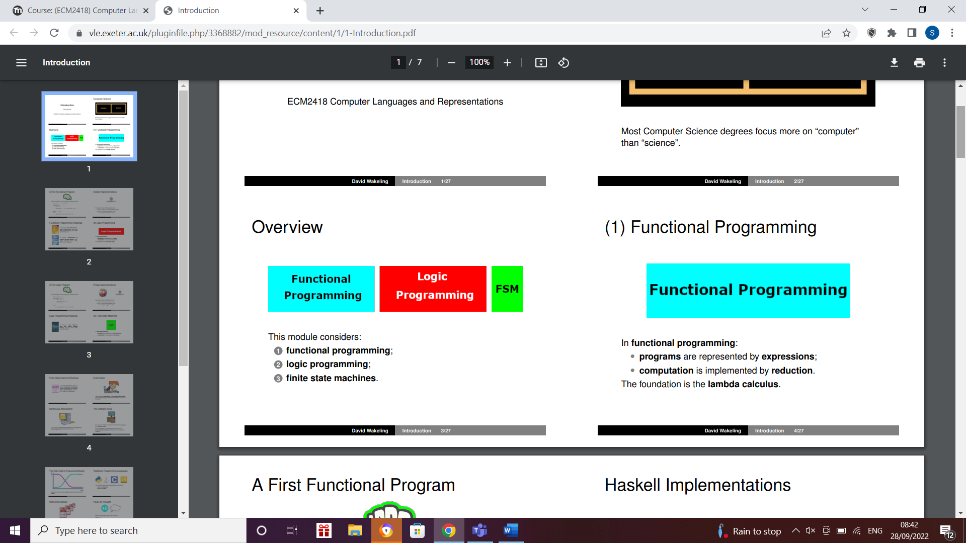

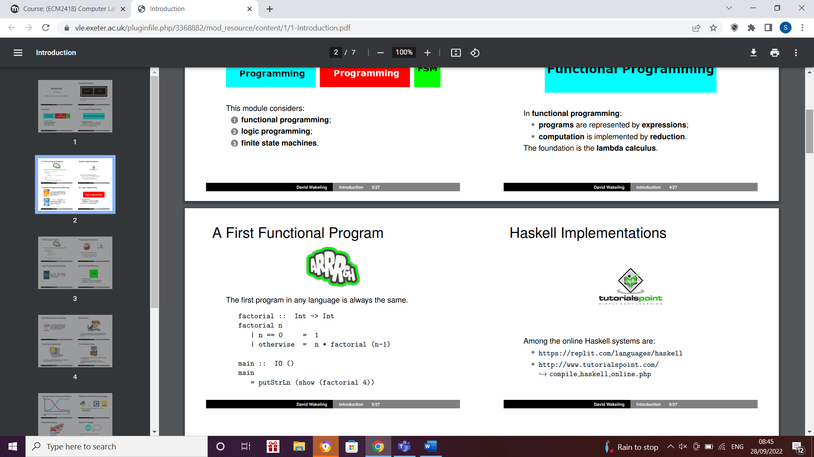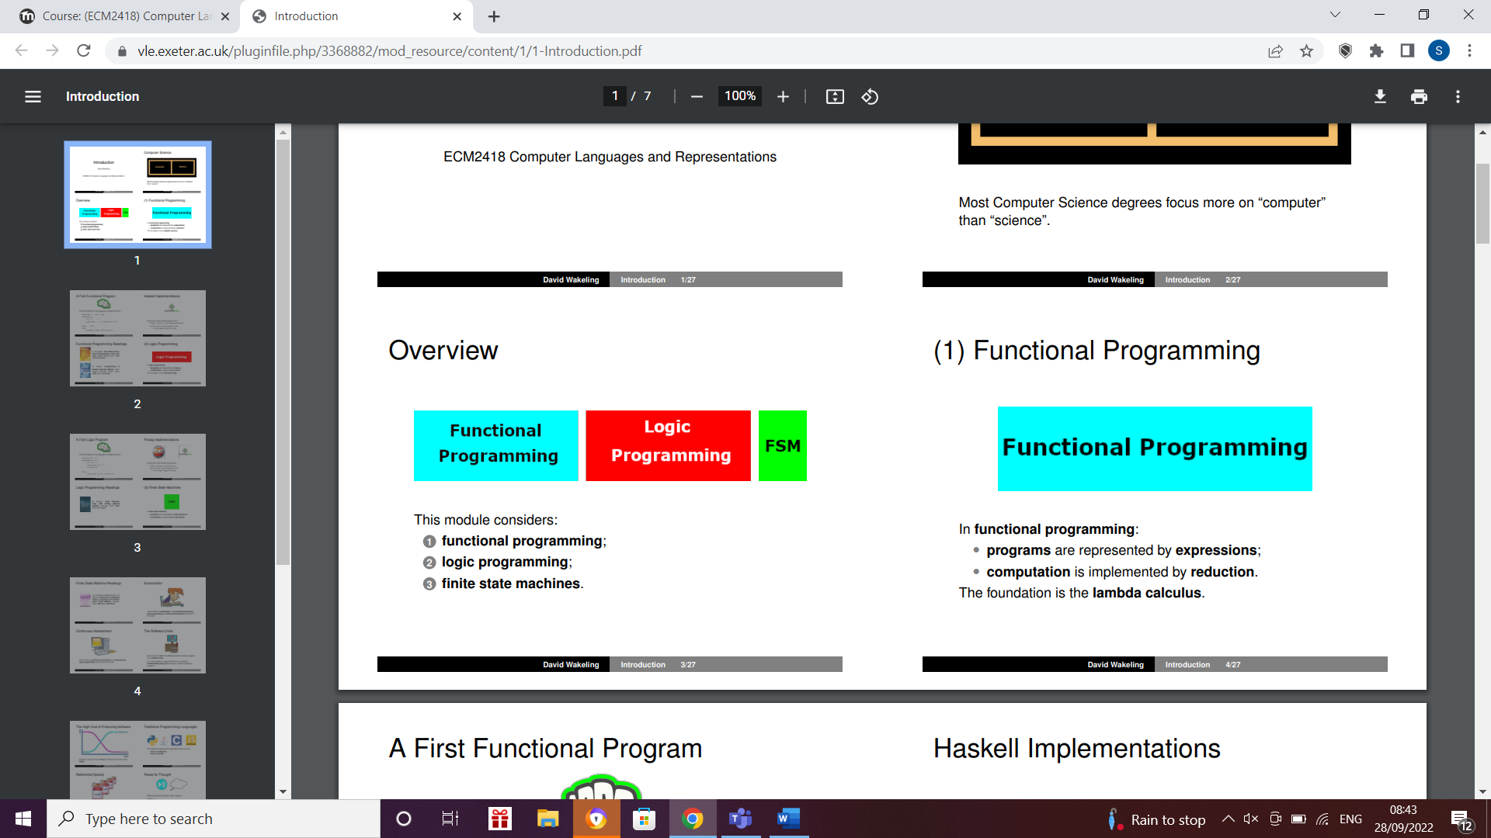

Haskell 3rd line saying factorial of 0 is 1

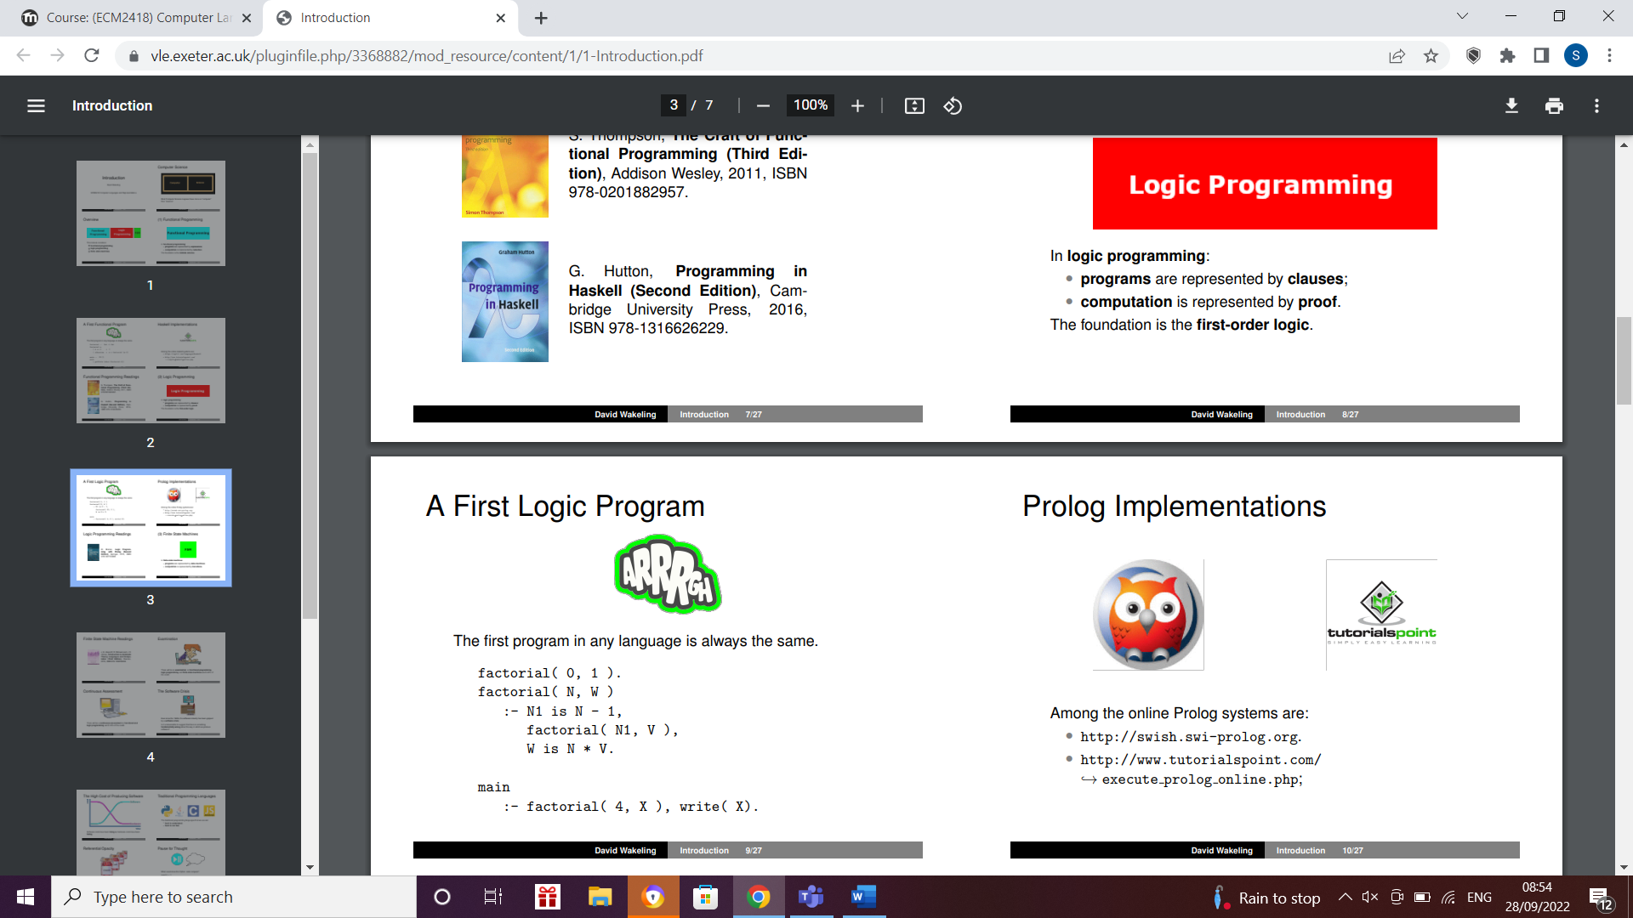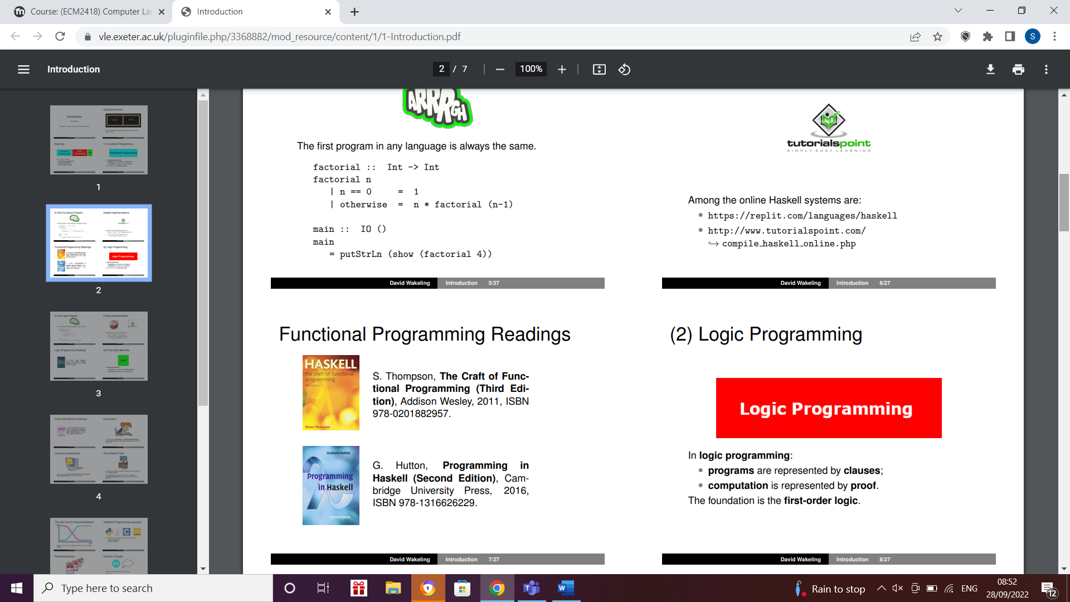

Prolog

Logic programming states facts

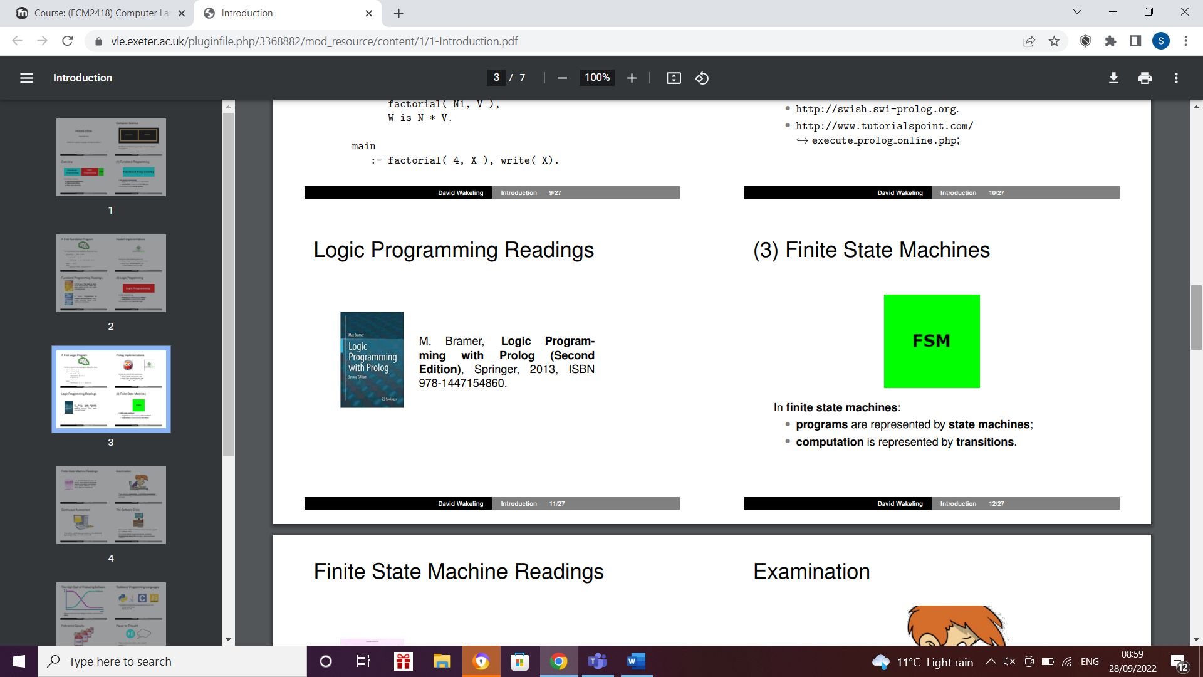

You can label the transitions to say when they happen

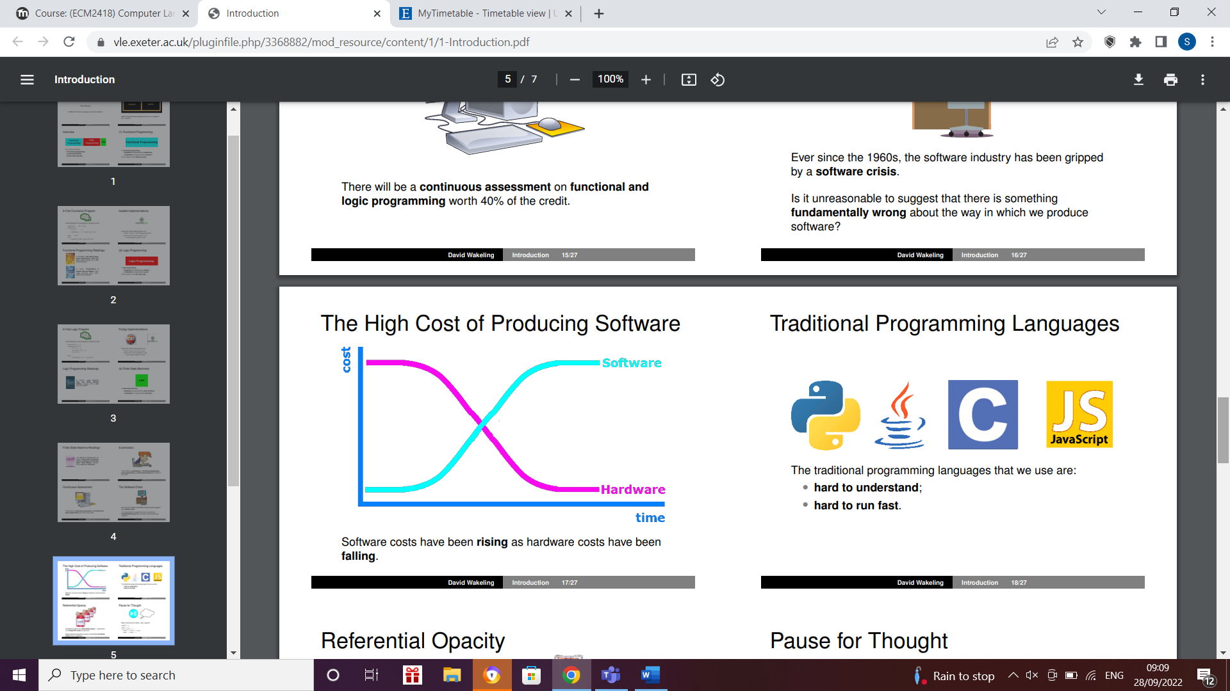

Software crisis- term used in the early days of computing science for **the difficulty of writing useful and efficient computer programs in the required time**.

So we produce computer software, people give us specifications, we read the specifications,

interpret them, perhaps we write some code, we show it to them, didn't like what they saw and there may be some kind of iteration around that because it is hard to understand

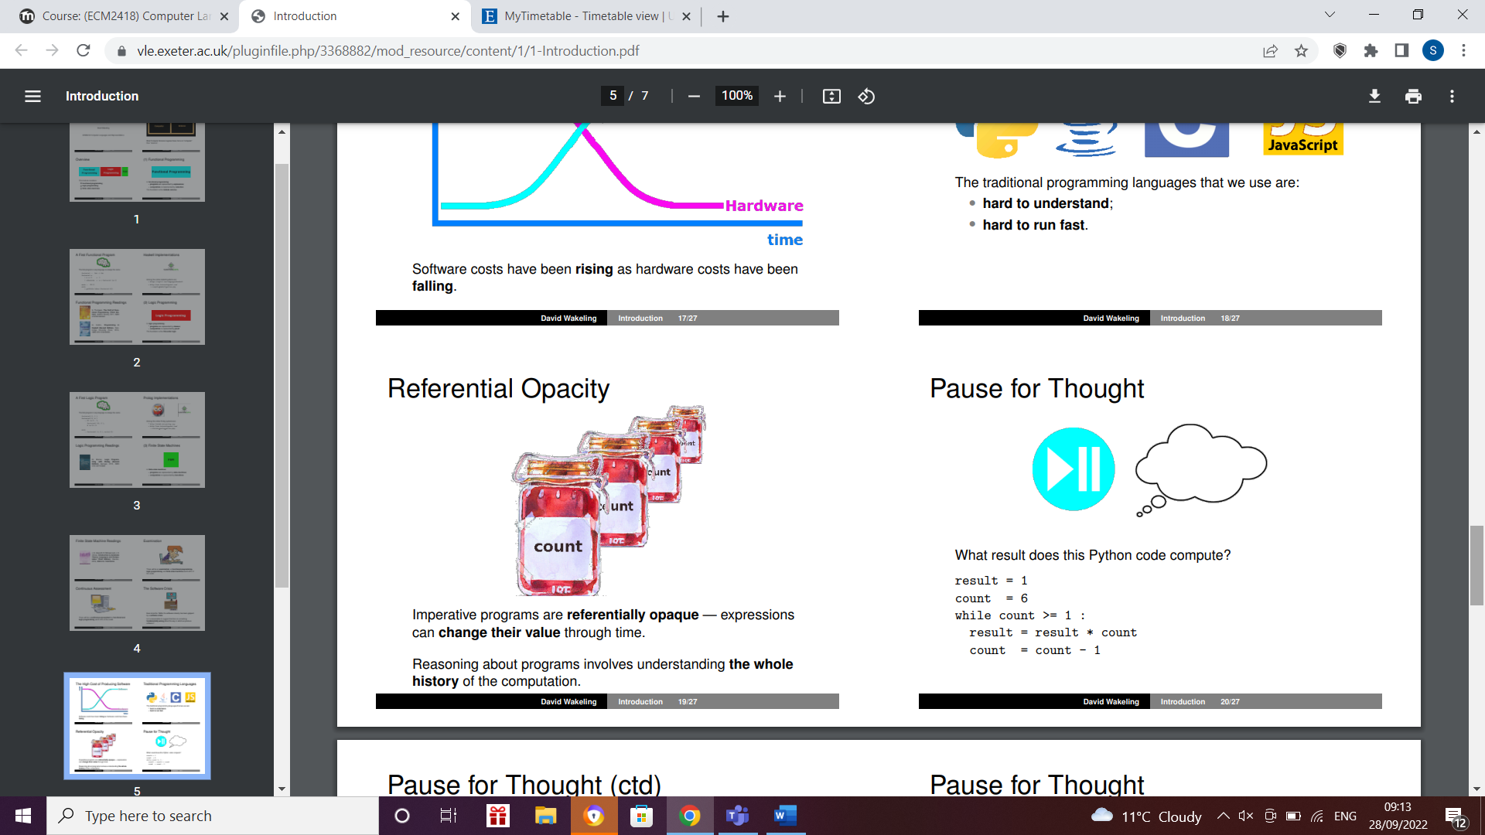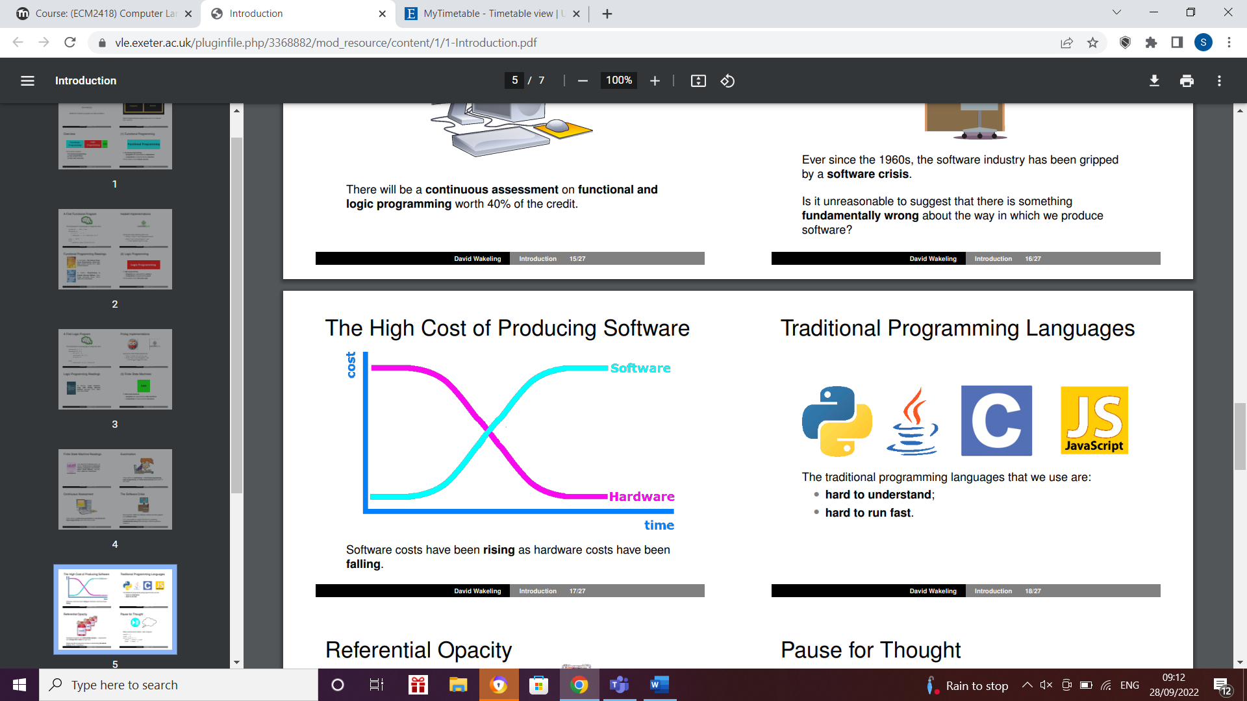

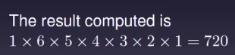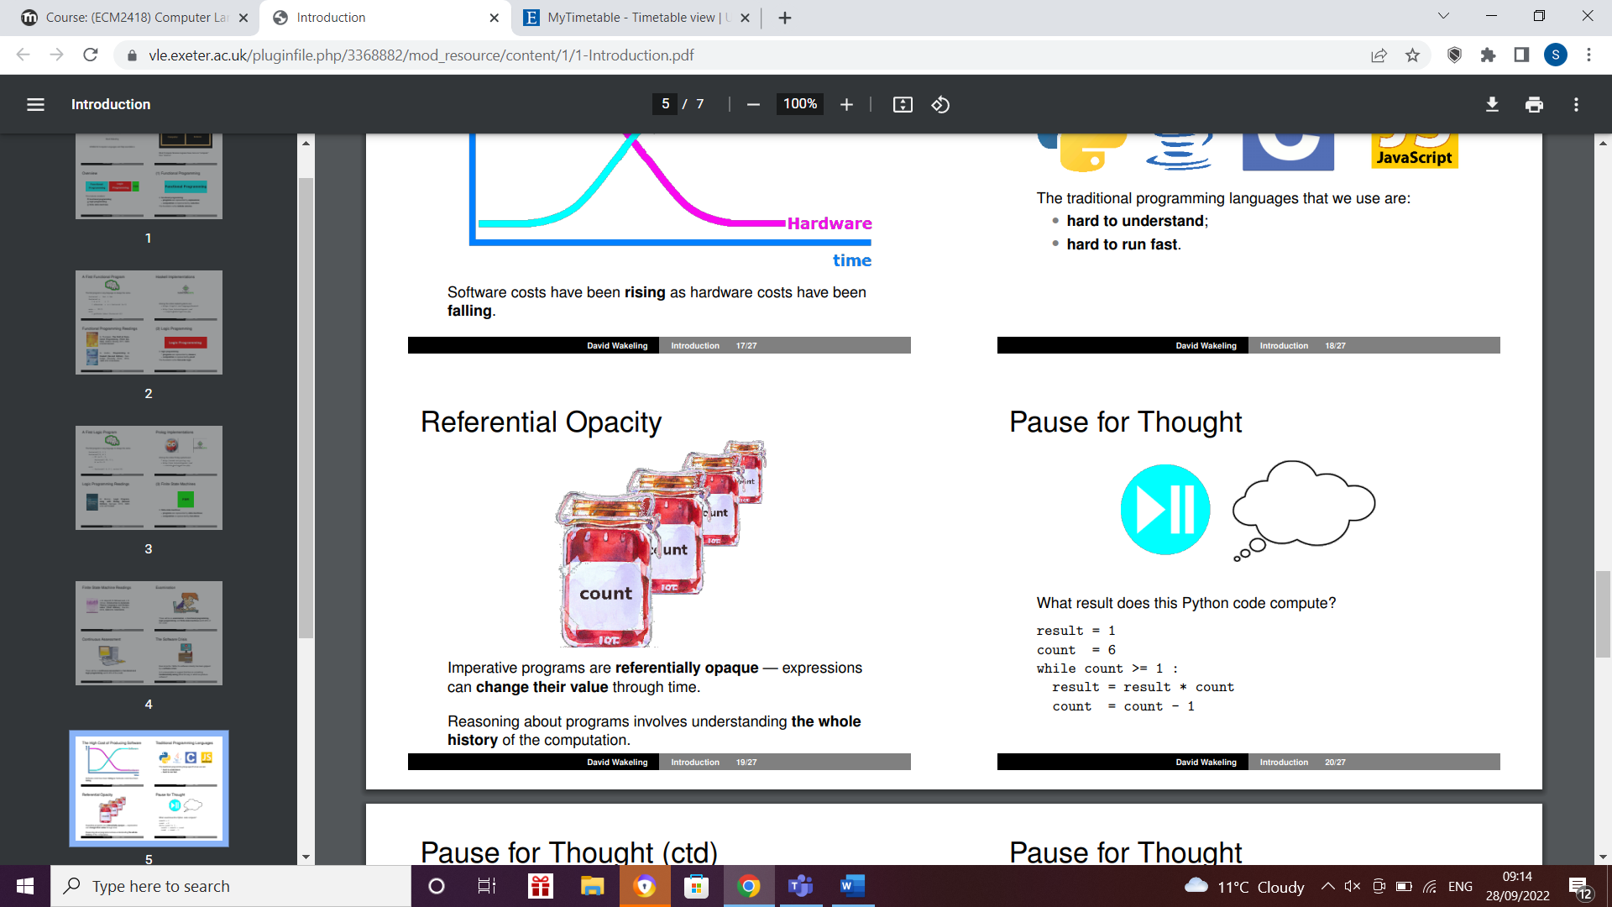

It is a factorial program

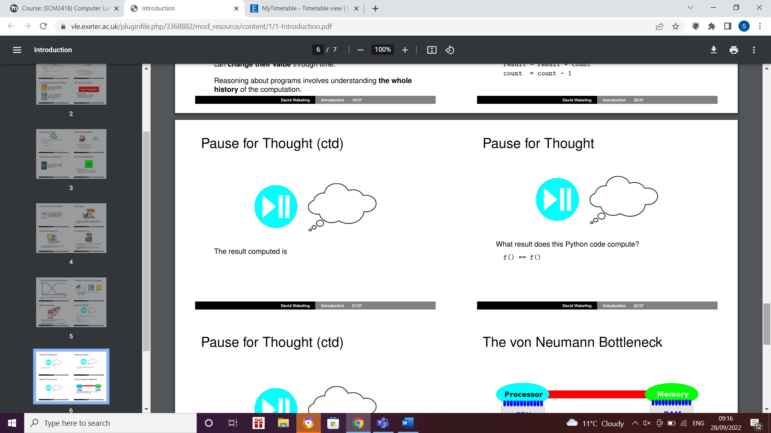

True or false?

Depends what f does so if f is a pure function without any side effects it is true

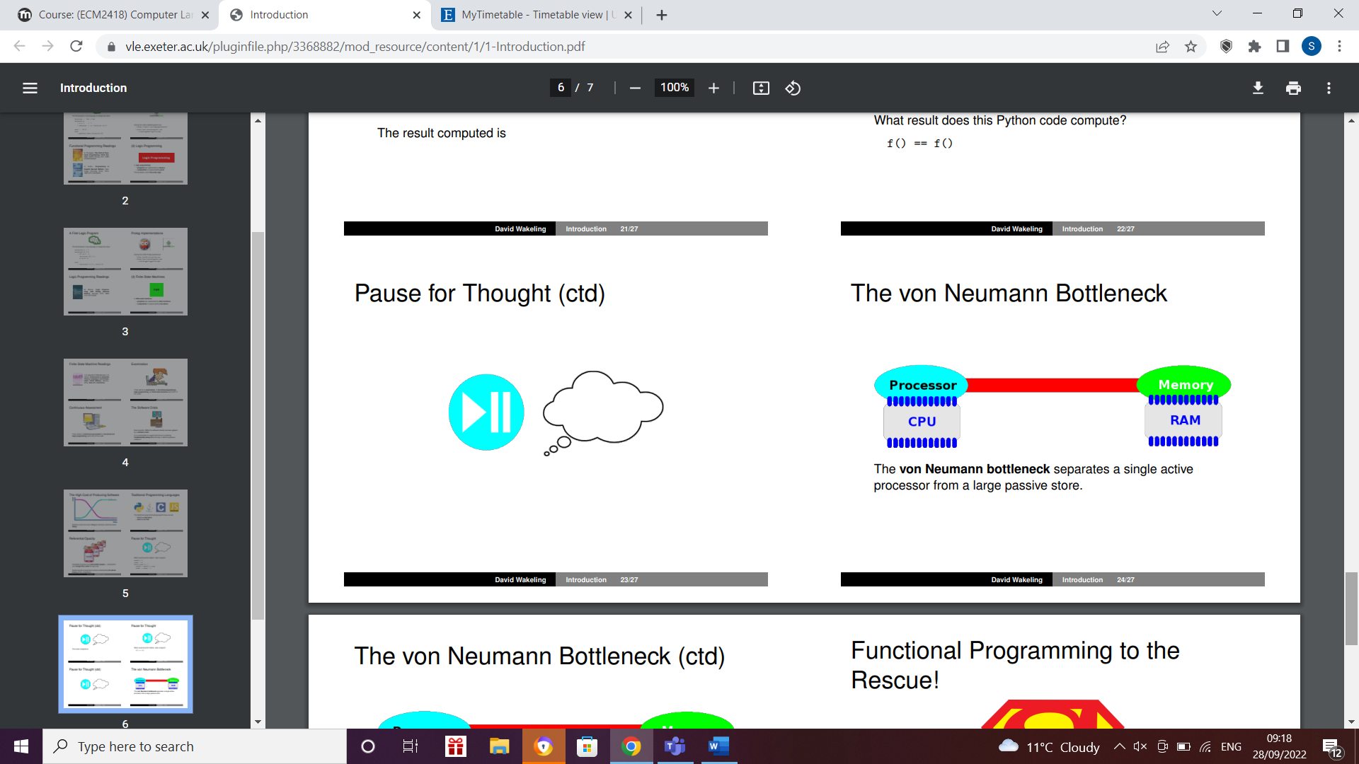

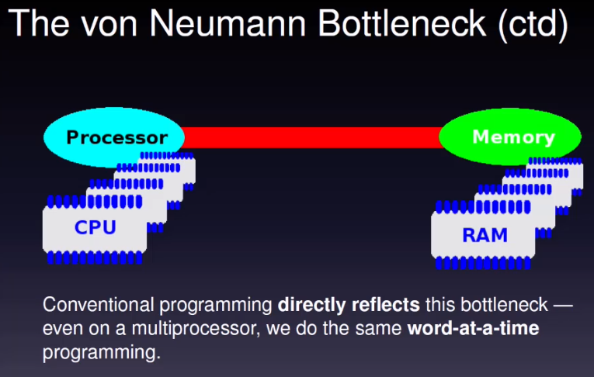

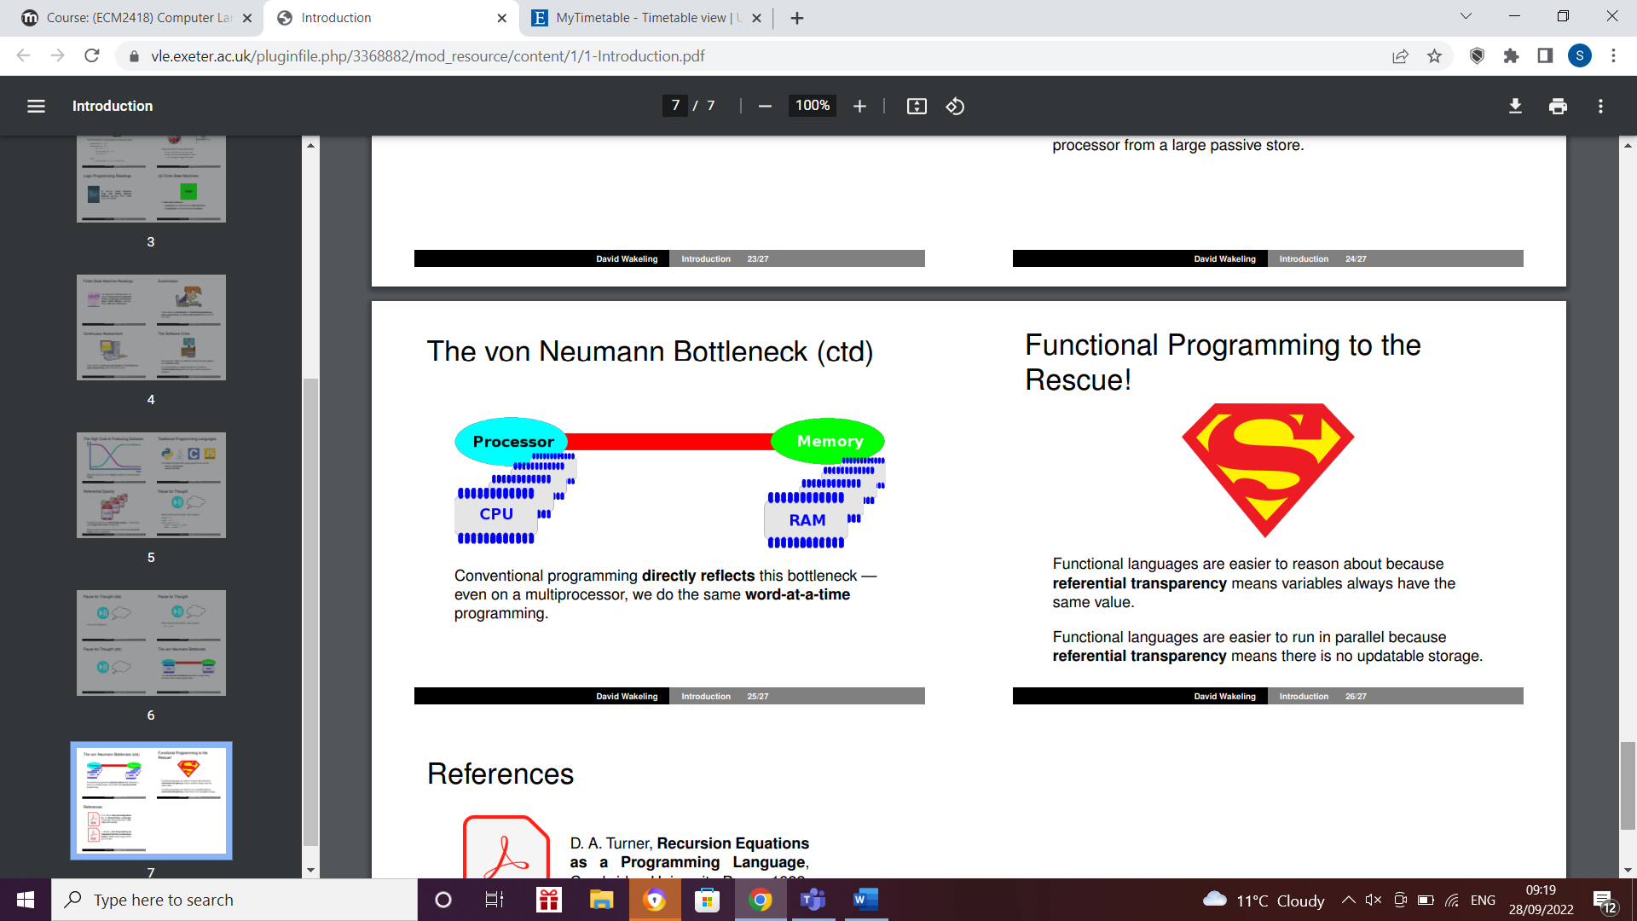

L2

https://recapexeter.cloud.panopto.eu/Panopto/Pages/Viewer.aspx?id=D30AC91F-F544-478D-B84E-AF1E010189A0

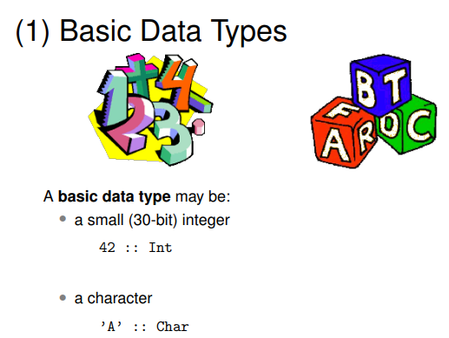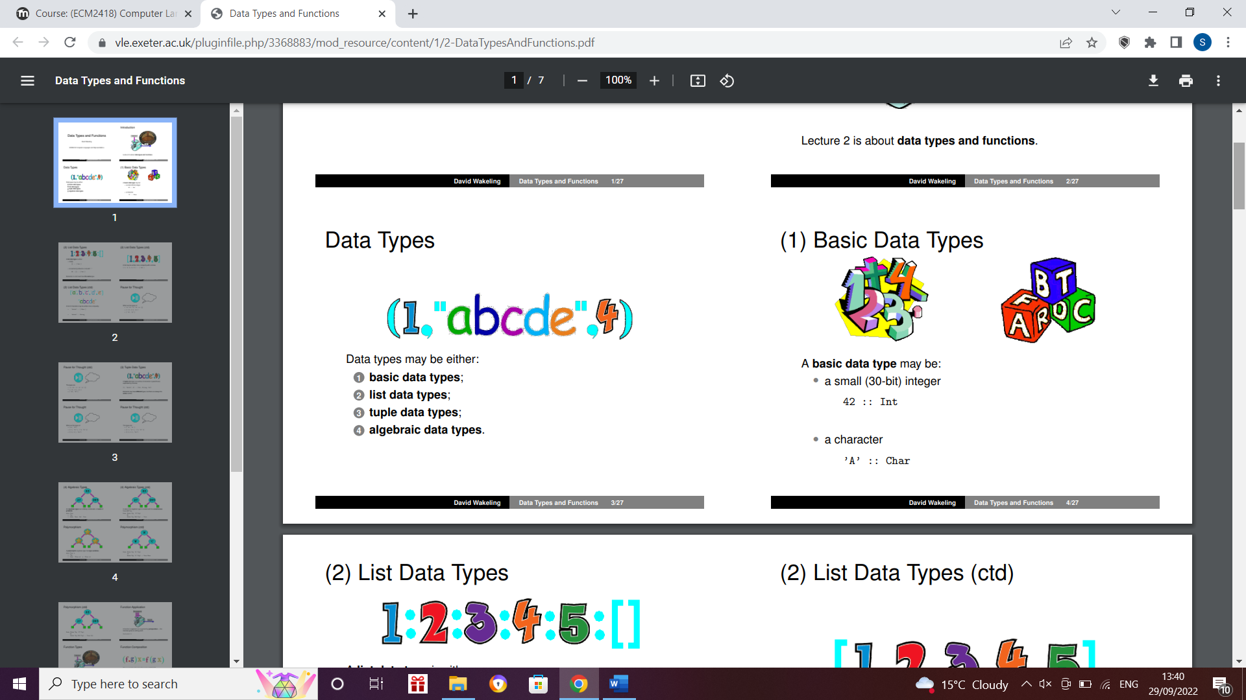

These are things like integers, characters and boolean.

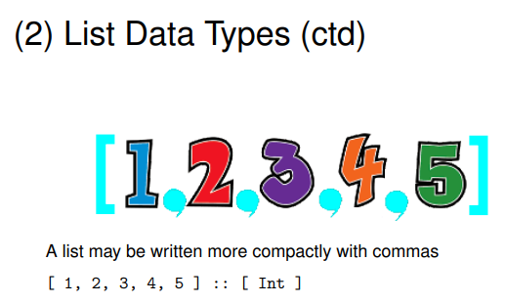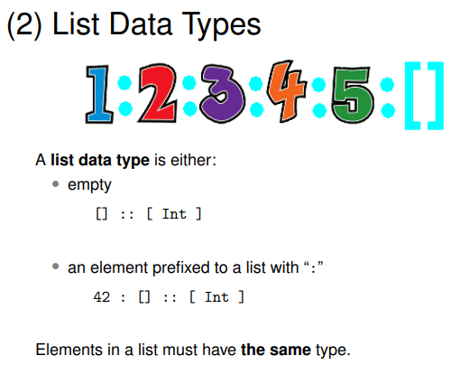

Head of the list is first element on that list

In this case integer 1

Tail of the list is all the other elements, in this case 2,3,4,5

: means joined onto another list

So e.g. on 2nd bullet point, 42 is joined onto an empty list

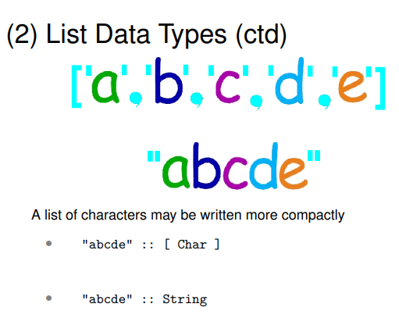

List of characters can be known as strings

In Haskell list of characters and strings are the same thing

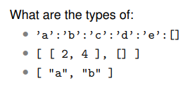

-String or list of characters

-List of lists of integers

-List of lists of characters or list of strings

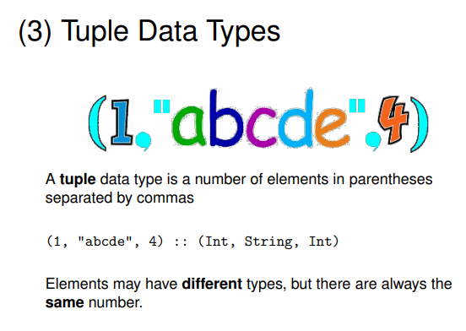

Tuple data types- elements do not have to have the same type but the size is fixed

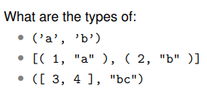

-Tuple with 2 characters

-List of tuples with integers and strings

-Tuple with list of integers and a string

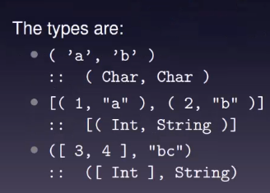

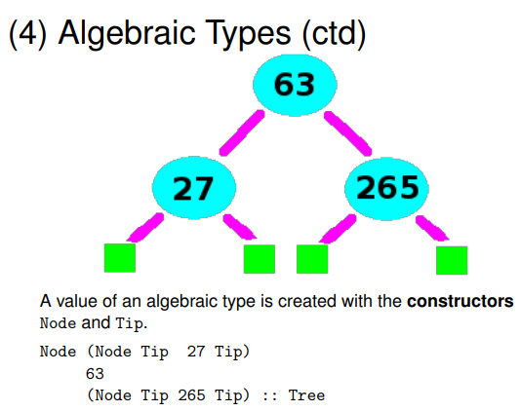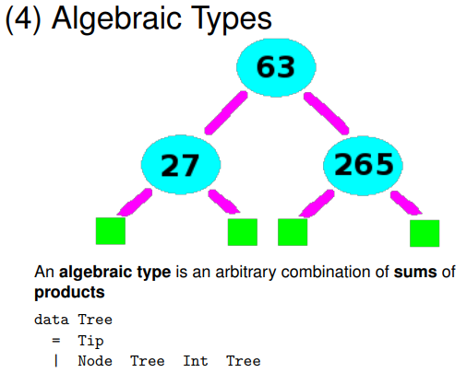

This binary tree has no root that stores integers

The code says we have data tree

The tree is either a tip

Or a node with an integer stored

So I can have nodes with trees in both side then I get to the end of the tree saying we are at the tip

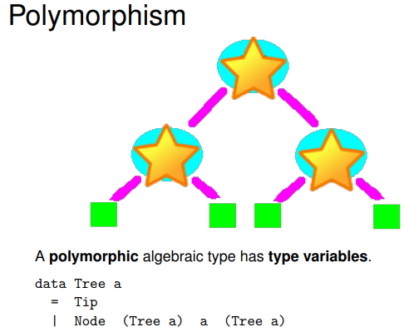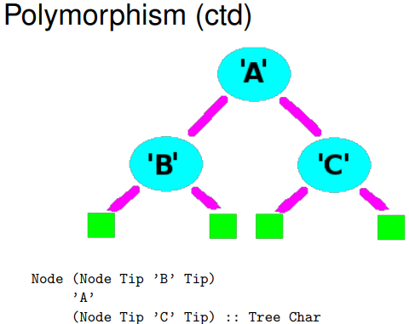

Polymorphic tree is a tree of any type e.g. it can be integer, Boolean or string

Polymorphism stops you from writing the same code repateadly

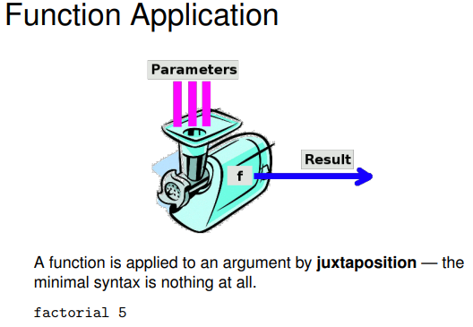

factorial 5 or other functions like these are the cheapest syntax that you can have

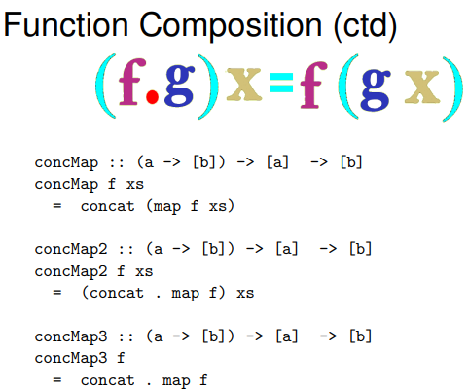To keep your programme concise you want the minimal syntax

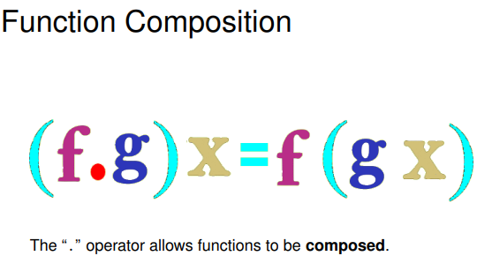

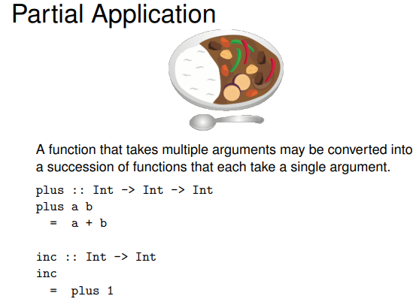

Alternative for inc is

inc x

= plus 1 x

But you can cancel arguments when they are the same

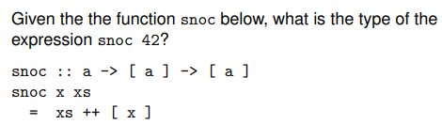

Week 2

Practical

Activity 1

“len” returns the length of a list of integers

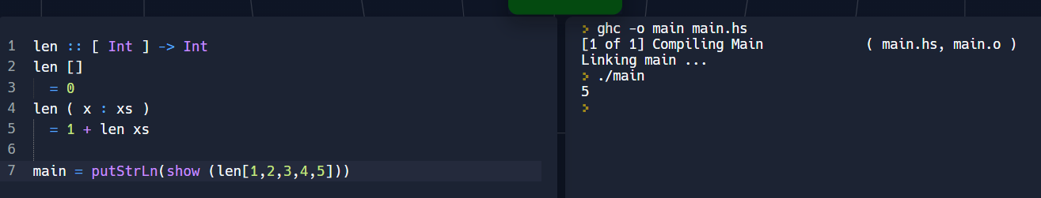

Activity 2

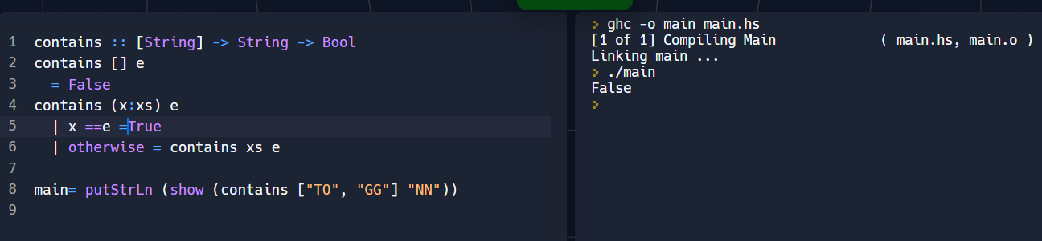

“contains” returns True if a string is in a given list of strings, otherwise “False”.

Activity 3

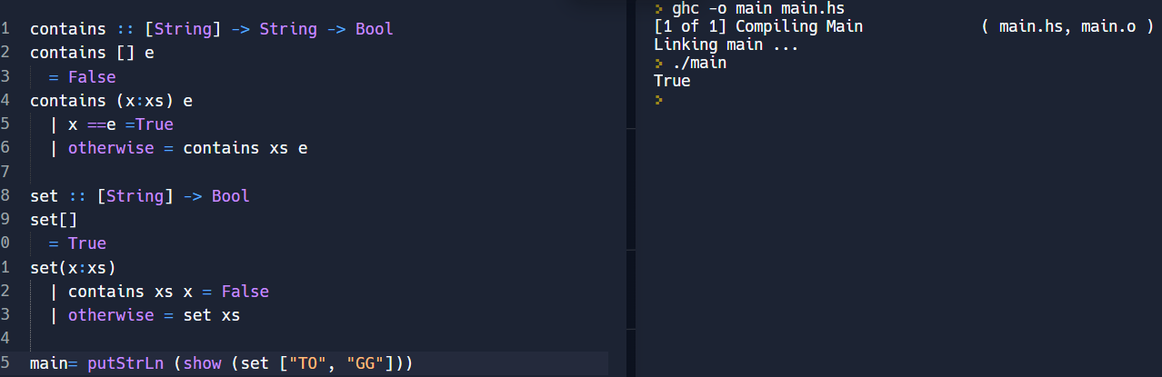

“set” returns “True” if no string occurs in a given list of strings more than once

Activity 4

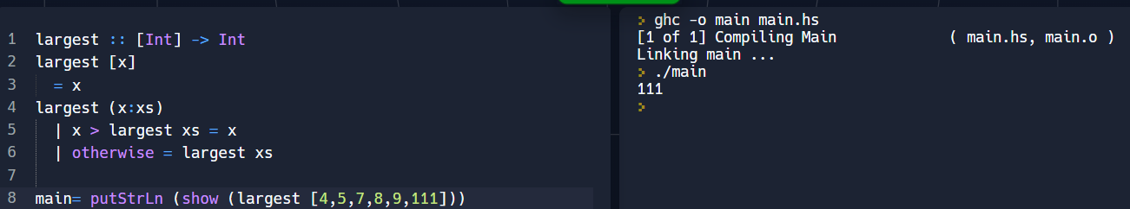

“largest” returns the largest integer in a list of integers

Activity 5

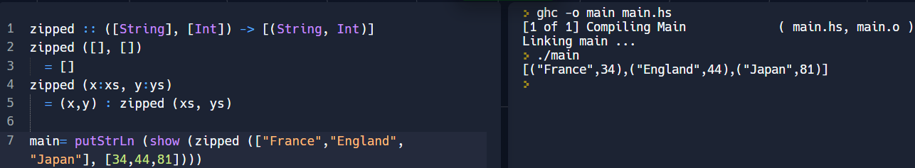

“zipped” zips a pair of lists of equal length together to give a list of pairs

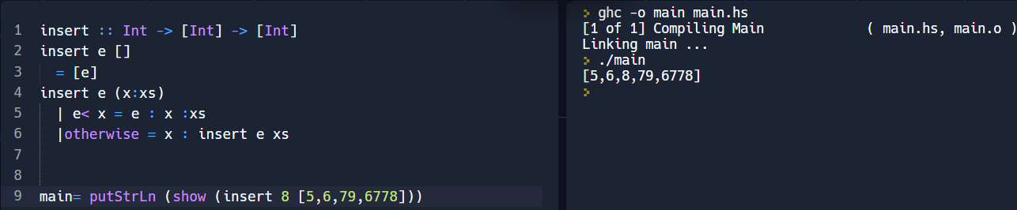Activity 6

“insert” inserts an integer into an ordered list of integers

Activity 7

“sort” sorts a list of integers into order

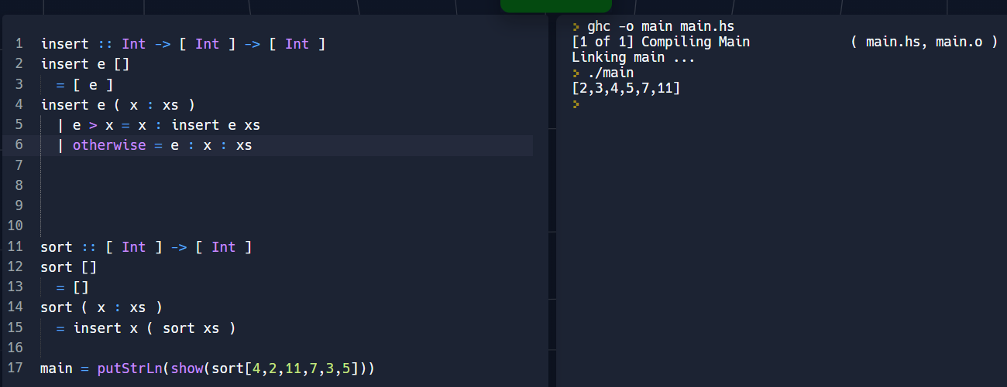

L1

https://recapexeter.cloud.panopto.eu/Panopto/Pages/Viewer.aspx?id=37848B85-D8F0-477A-BBE8-AF240100D4EB

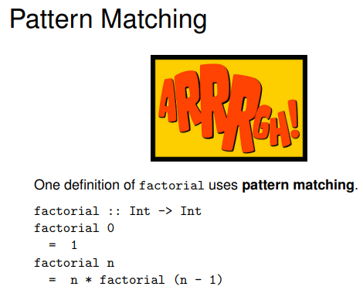

The pattern matchers are integers

n matches any integer

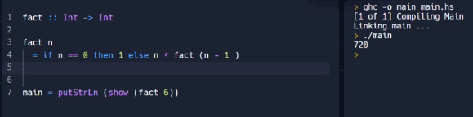

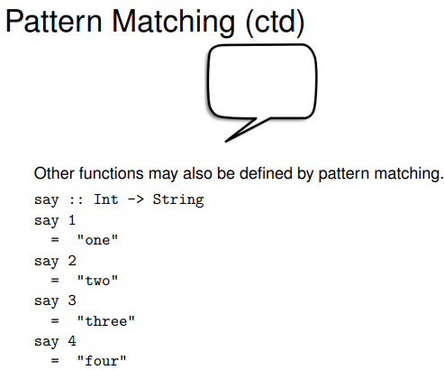

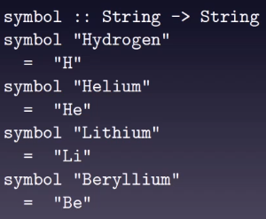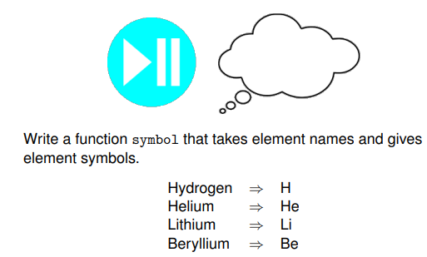

Strings are not a good plan in general

They should be your last choice for representing data

String are not a great choice for representing data as it takes more space and it is difficult to operate on

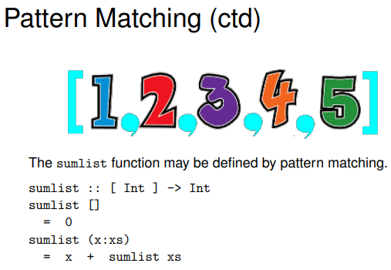

This takes a count of x and it adds it up

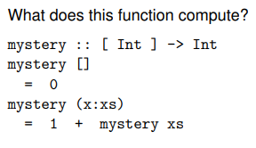

With this it counts to 1 every time it sees an x

It computes the length of the list

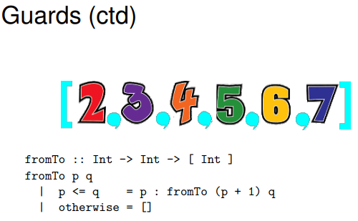

Guards is something of a Boolean value

3rd line: if the guard is true then we choose the right hand side

4th line: the very last guard is otherwise and that is always true

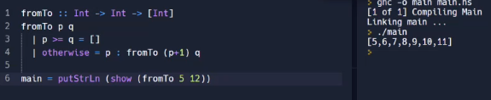

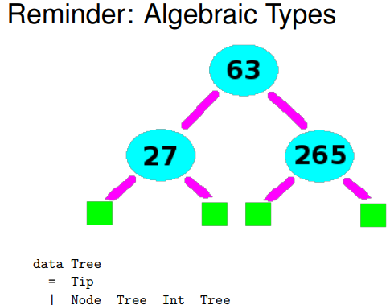

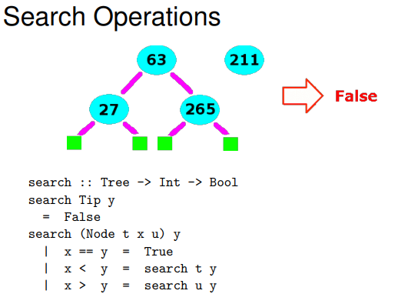

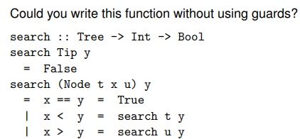

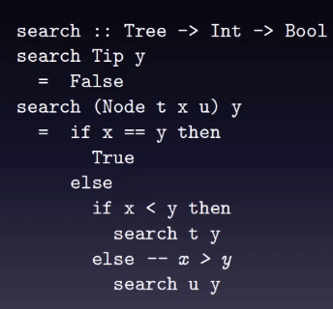

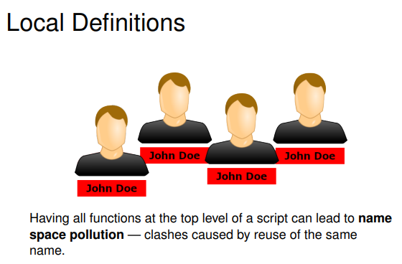

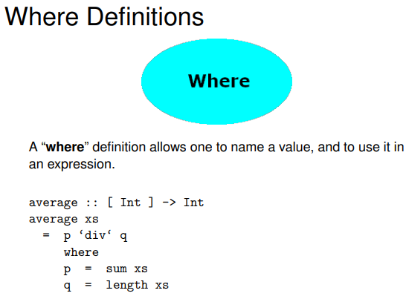

where gives you a chance to differ complexity

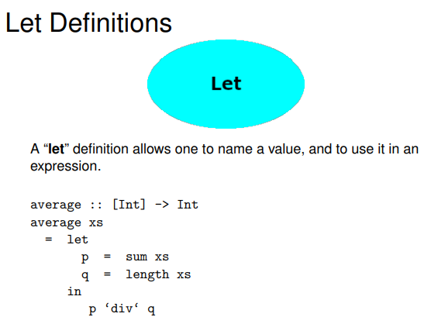

L2

https://recapexeter.cloud.panopto.eu/Panopto/Pages/Viewer.aspx?id=D12D2709-88A7-45CC-8EF8-AF2501015F4B

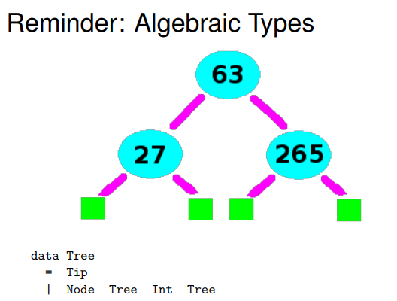Type Classes

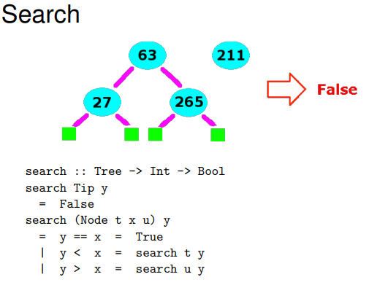

If you’re looking for what is less than current node go left

If you’re looking for what is more than current node go right

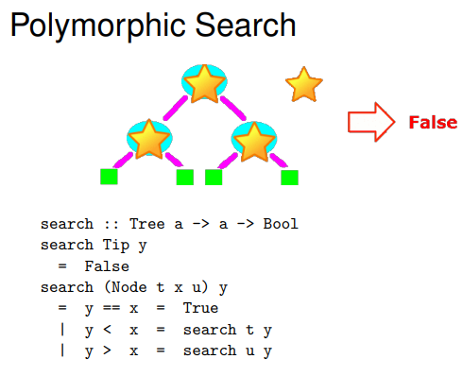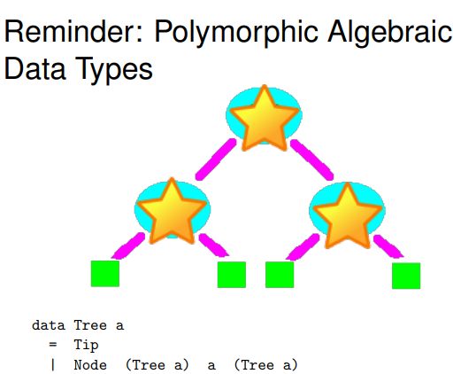

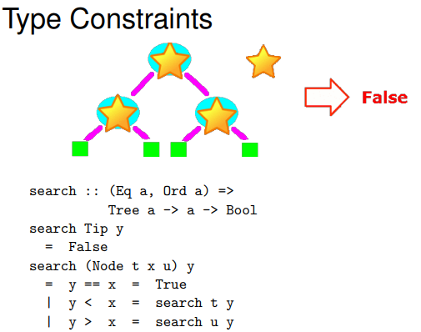

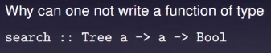

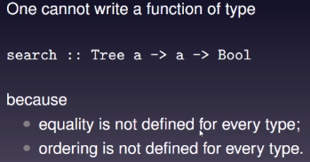

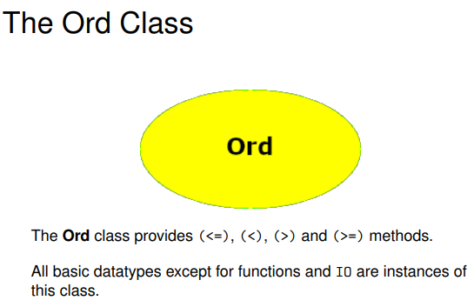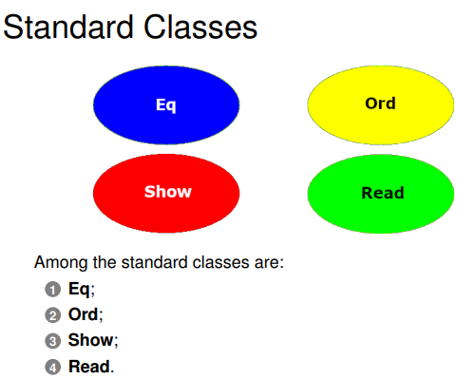

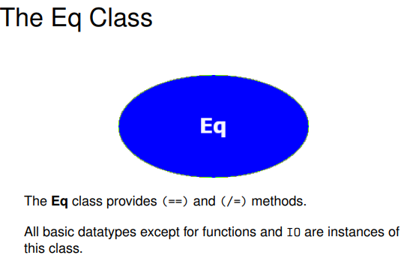Everything has got an equality operator except for functions and I/O

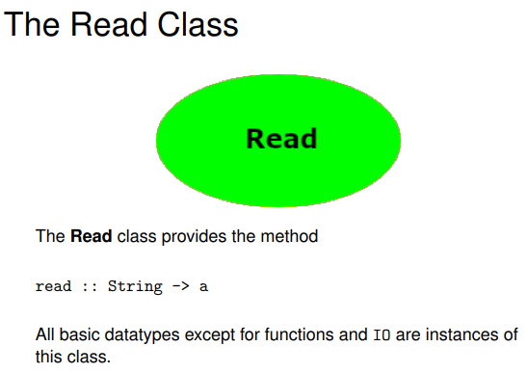

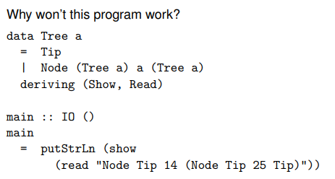

If I want to use classes with the data types I have to use deriving

With read, it converts a text into a type

By adding the words ‘deriving’, ‘show’ and ‘read’, we are saying we want to print this type and I ant to read it from input

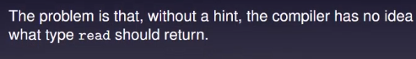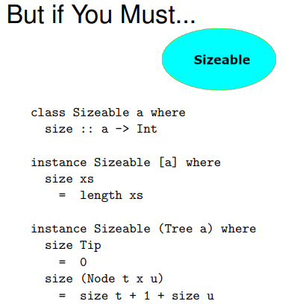

This also doesn’t have double colon which shows the type

Sizable is anything I can give a size to

First Instance of Sizable is lists

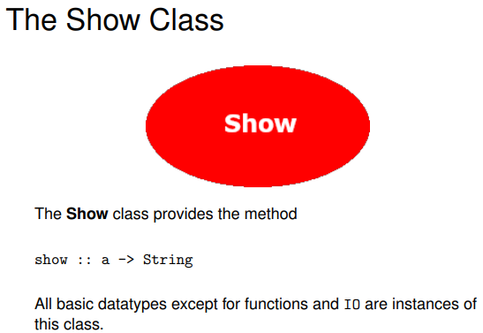

Anything inside the show class you can print

Week 3

Practical

insert

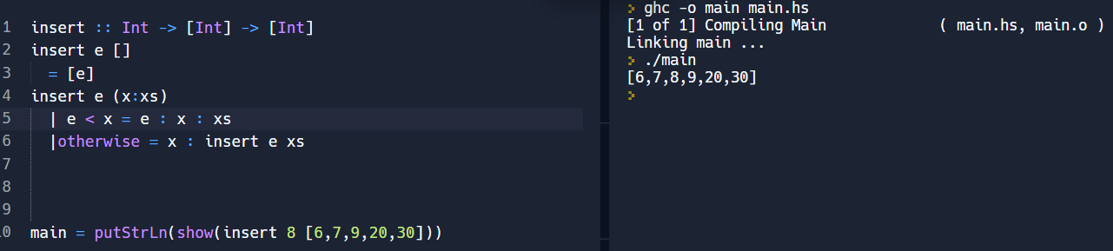

Sort

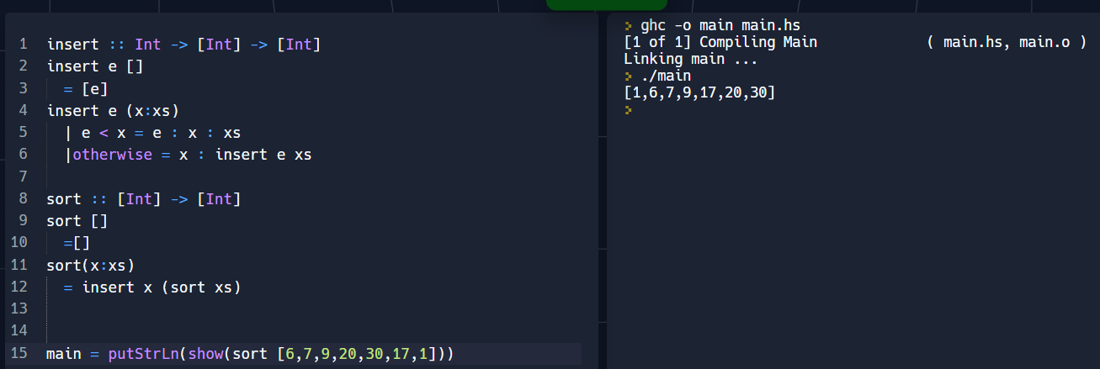

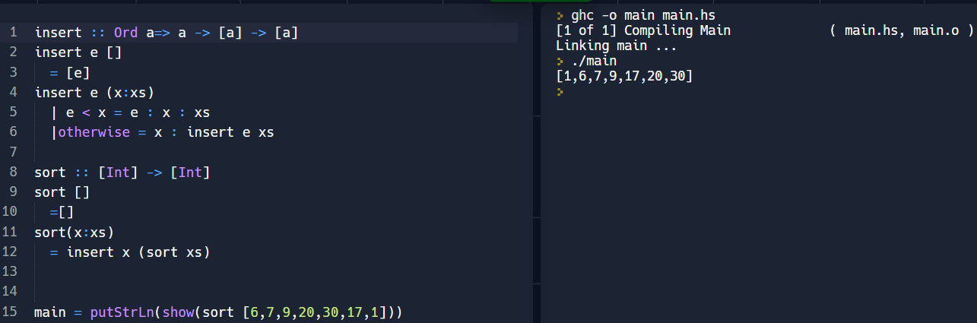

Activity 1

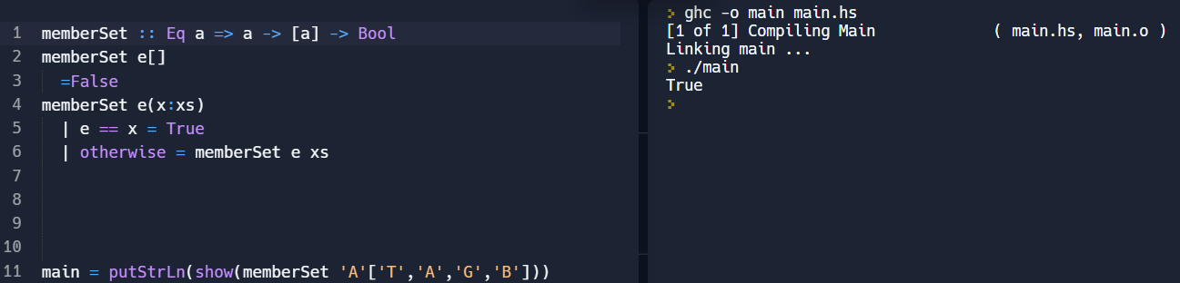“memberSet” used to test for set membership

Activity 2

“unionSet” used to find the union of two sets

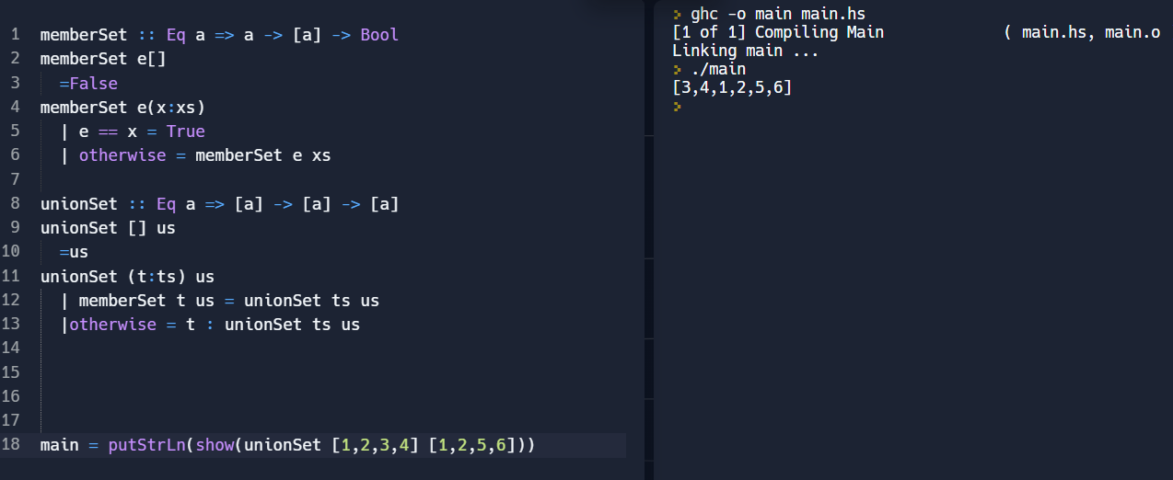

Activity 3

“interSect” used to find the intersection of two sets

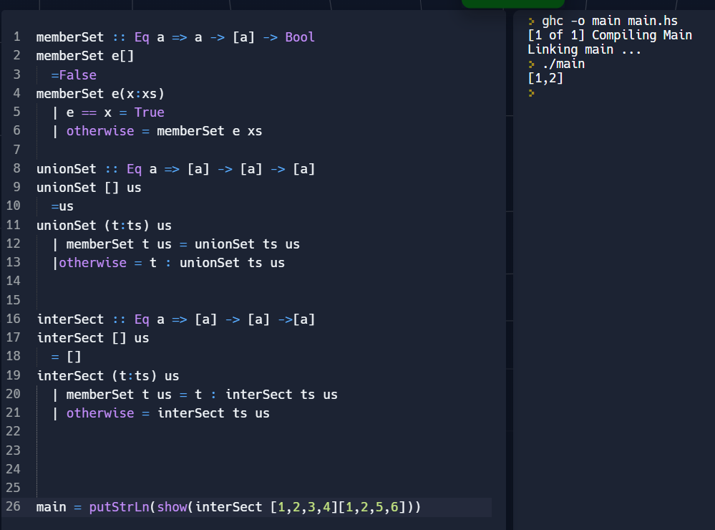

Activity 4

“takeList” takes n elements from a list, if possible

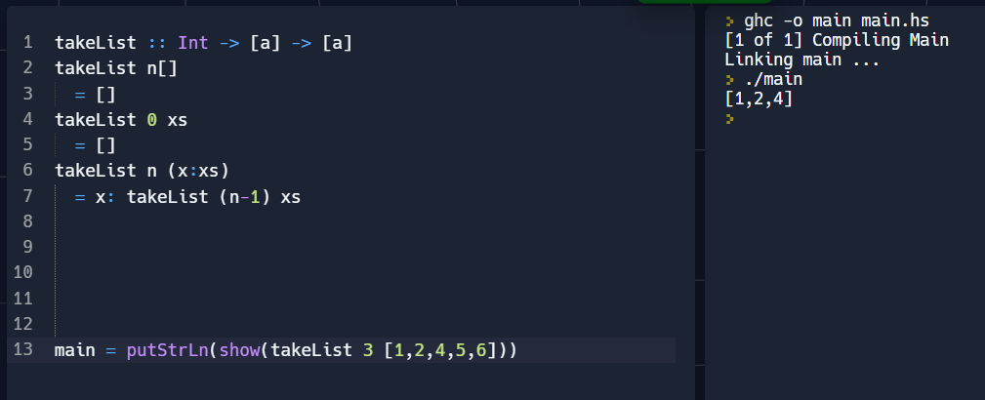

Activity 5

“dropList” drops n elements from a list, if possible

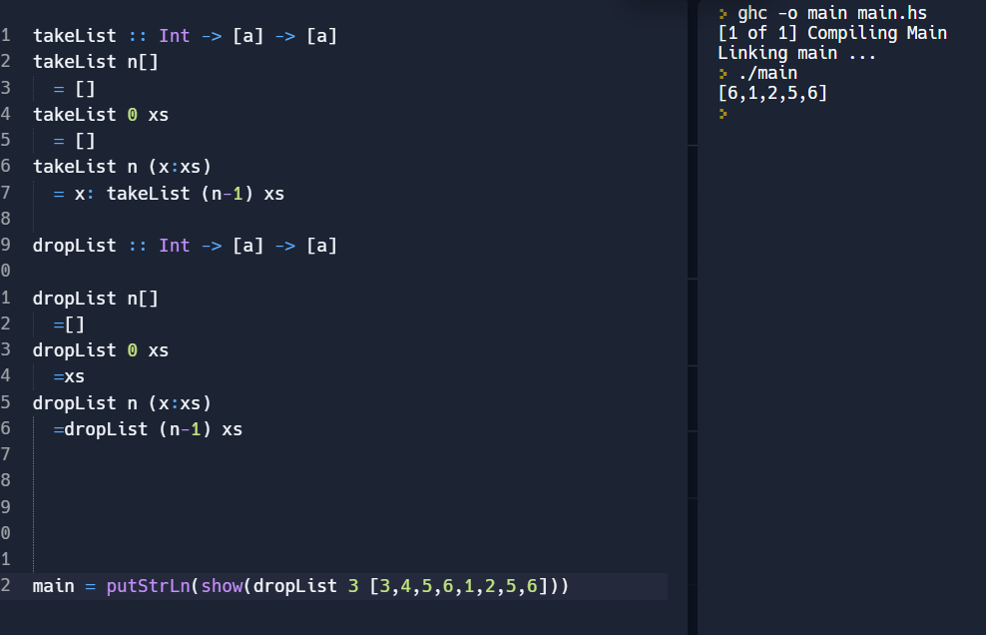

L1

https://recapexeter.cloud.panopto.eu/Panopto/Pages/Viewer.aspx?id=3144A19B-1B13-45CD-9608-AF2B0100E651

High Order Functions

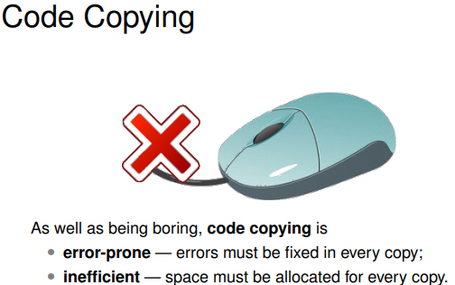

High order functions will give the ability to avoid code copying

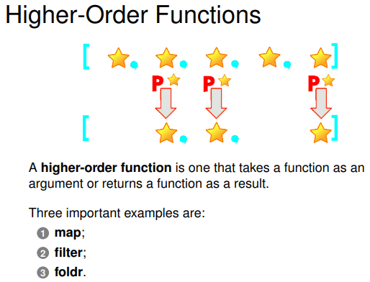

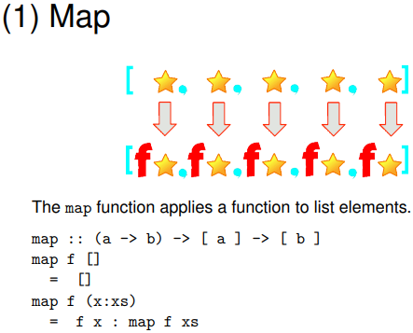

Star is anything you like

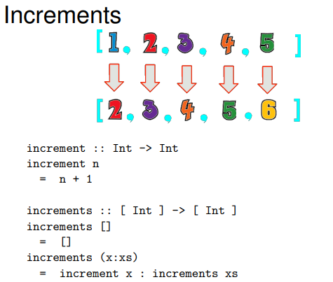

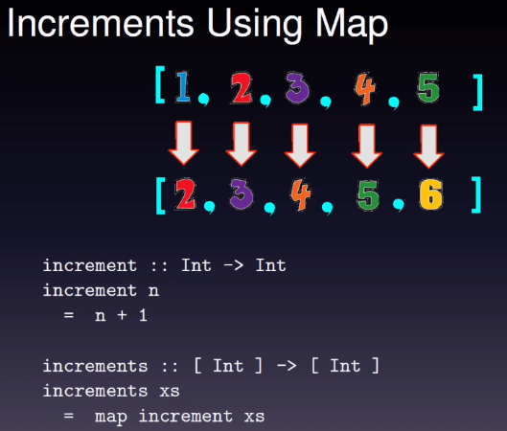

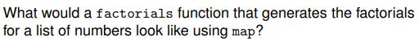**?**

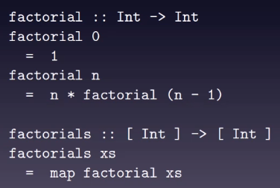

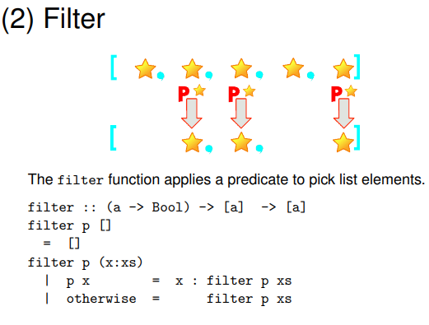

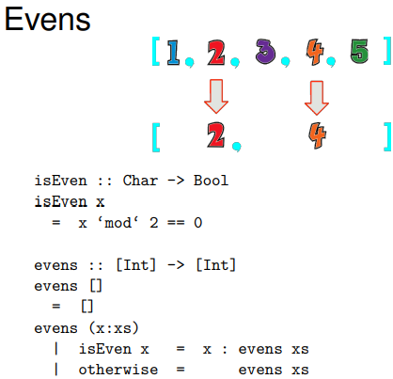

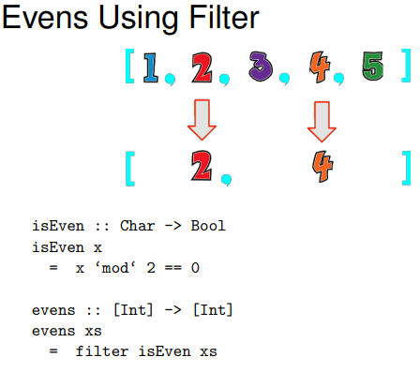

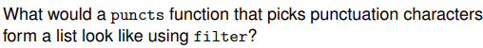?

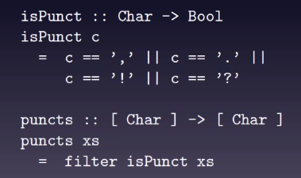

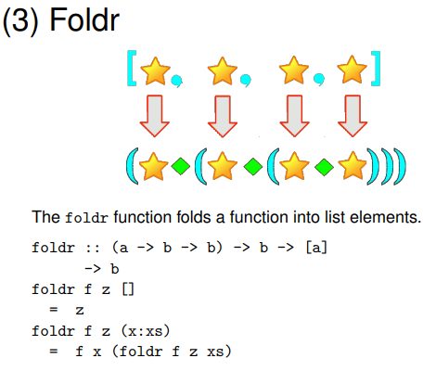

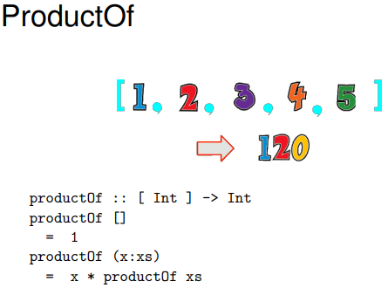



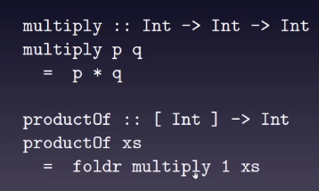

Shorter code is much better until you have to correct things in the code

* It is easier to understand with shorter code

L2

https://recapexeter.cloud.panopto.eu/Panopto/Pages/Viewer.aspx?id=53A620BE-EF38-455E-8DE5-AF2C010168F1

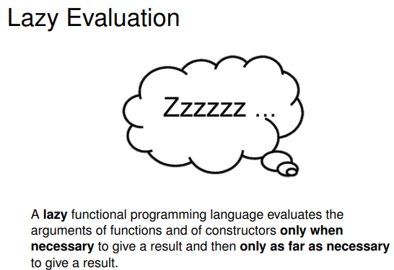Lazy Evaluation

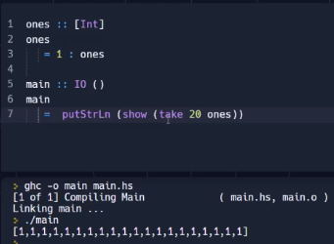

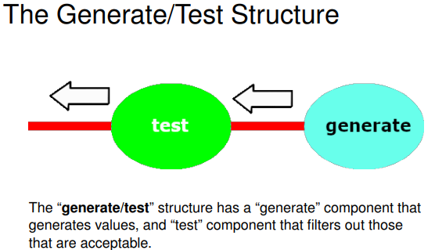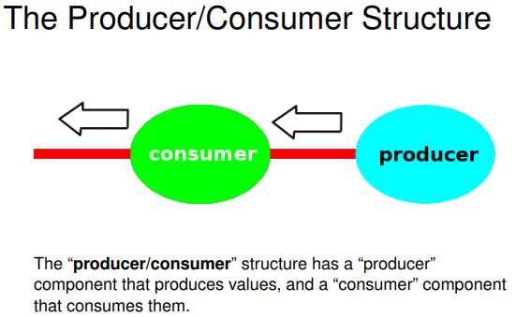

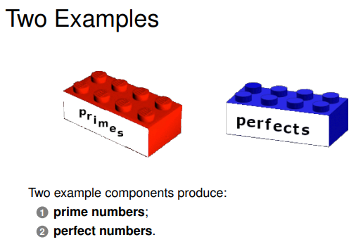

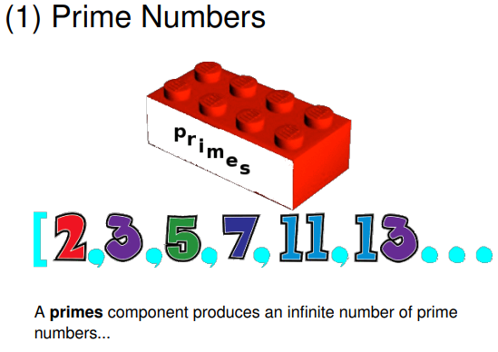

We can get away from infinite prime numbers by lazy evaluation

This means you explore finite portion of the infinite list

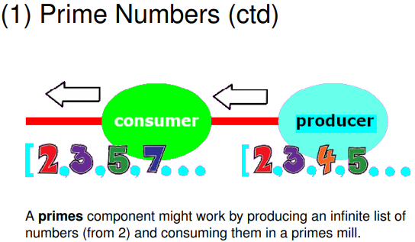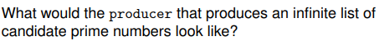

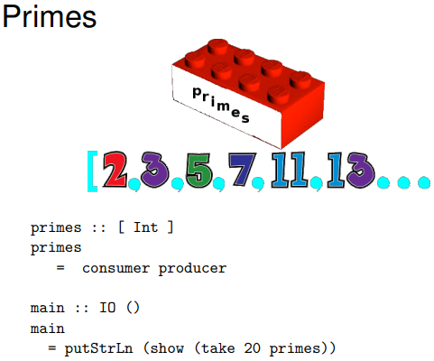

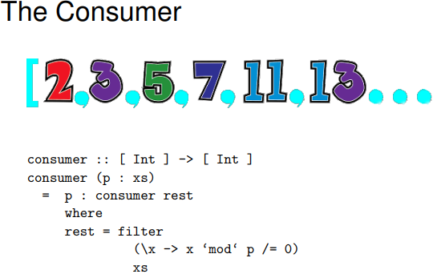

The primes component itself does not specify how many primes it wants

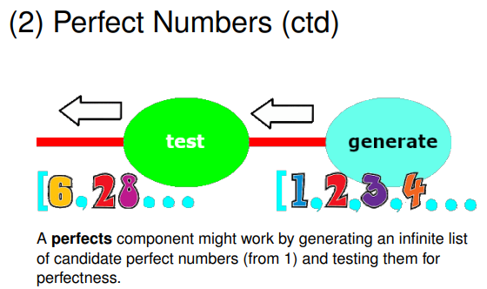

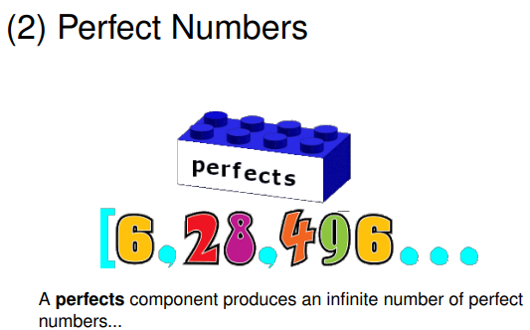

Perfect numbers- you factorise the number and you add up the factors

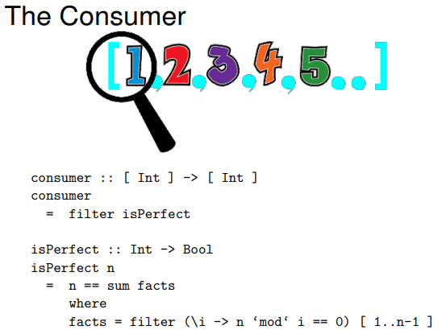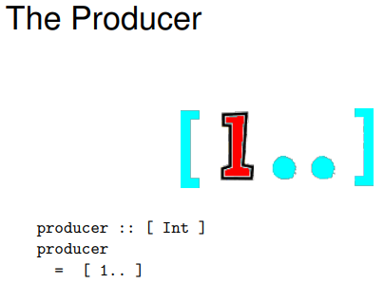

Filter will go through all the integers and take those which are perfect

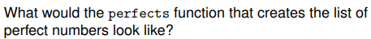

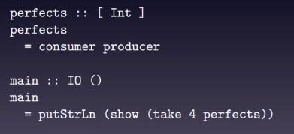

Week 4

Practical

Activity 1

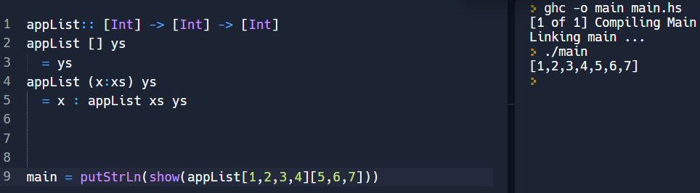“appList” takes two lists of integers and returns a single list of them appended together

Activity 2

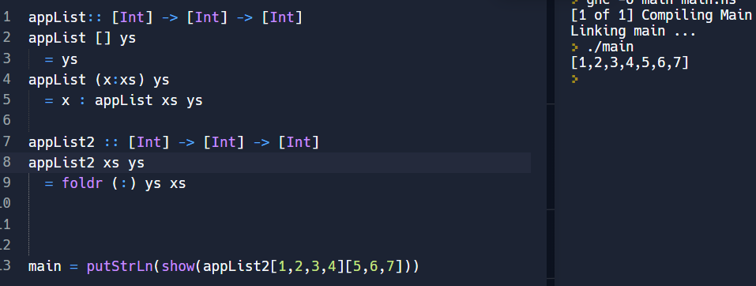

appList2 is the same as appList1

appList2 is better than appList1 because it is shorter and there is no recursion

*Avoid recursion

Activity 3

“concatList” takes a list and produces a new one with one level of list structure removed

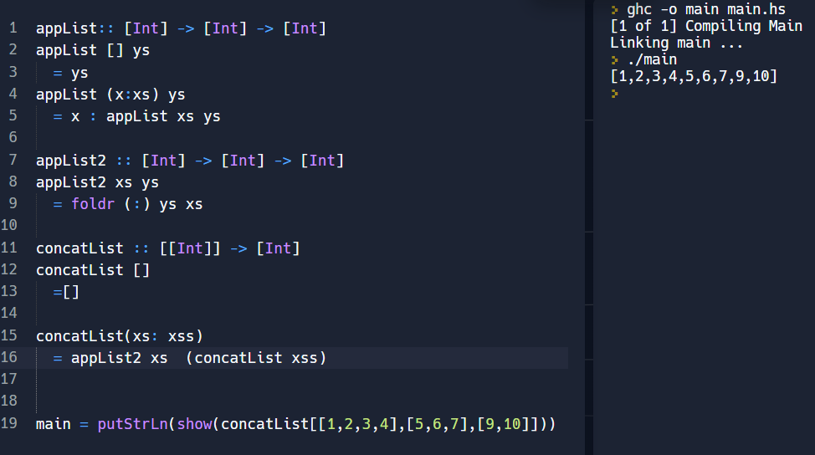

appList merges lists together

xs:xss – the thing itself in the front is a list

Activity 4

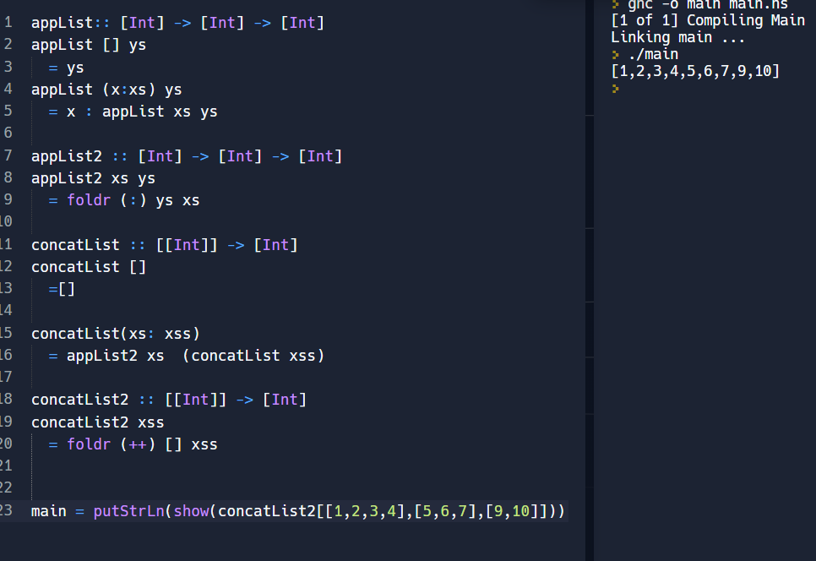

Activity 5

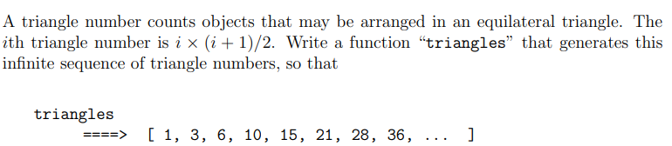

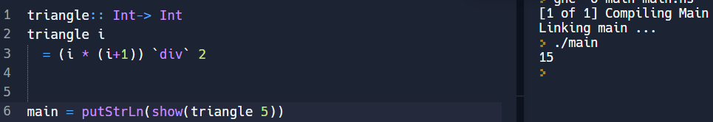

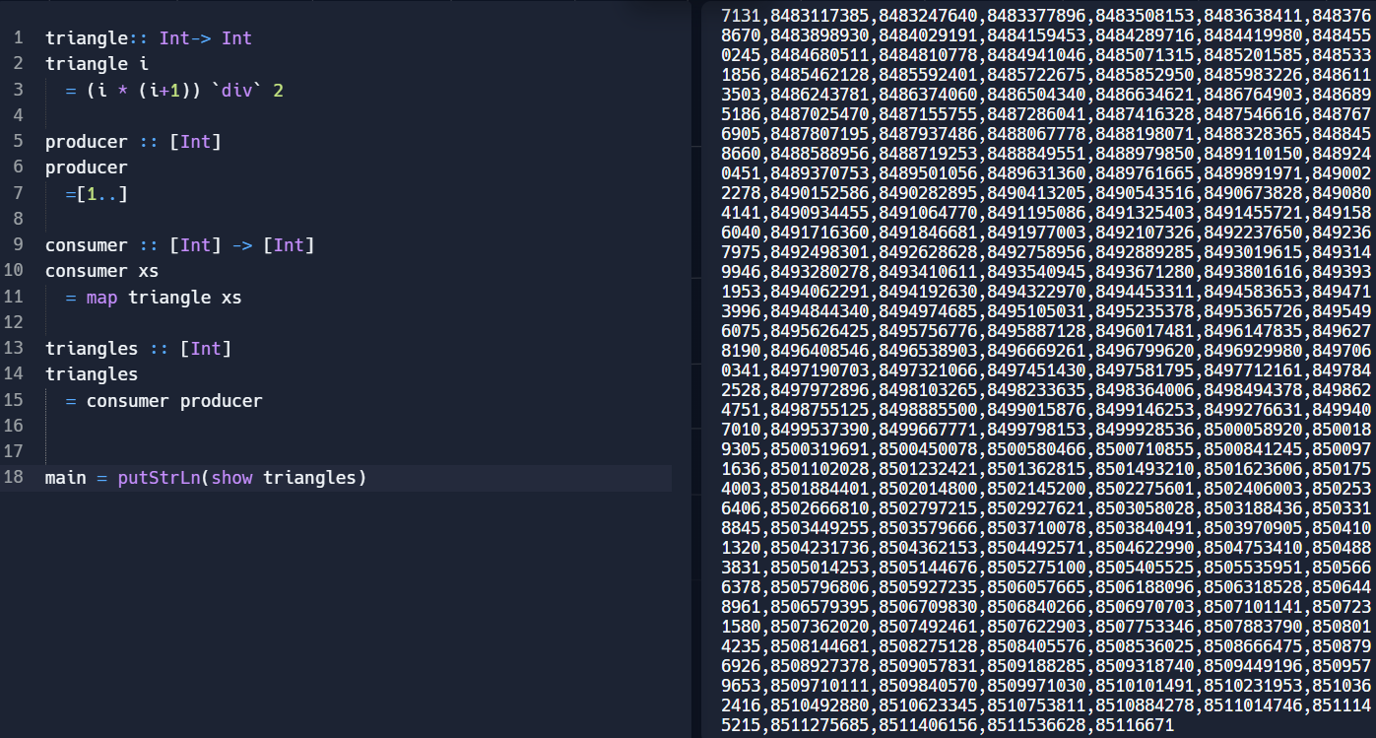

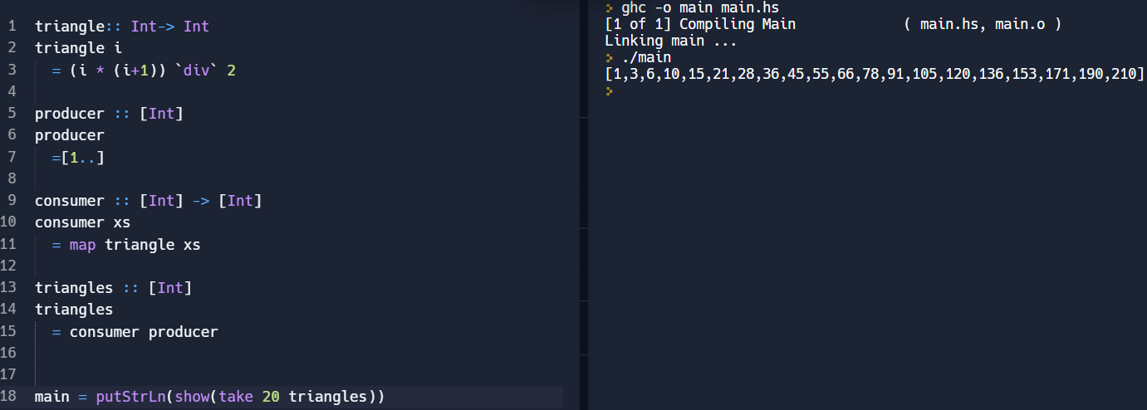

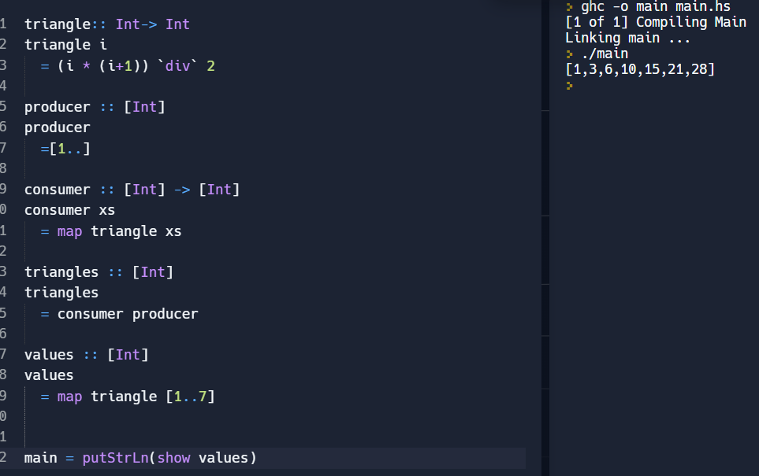

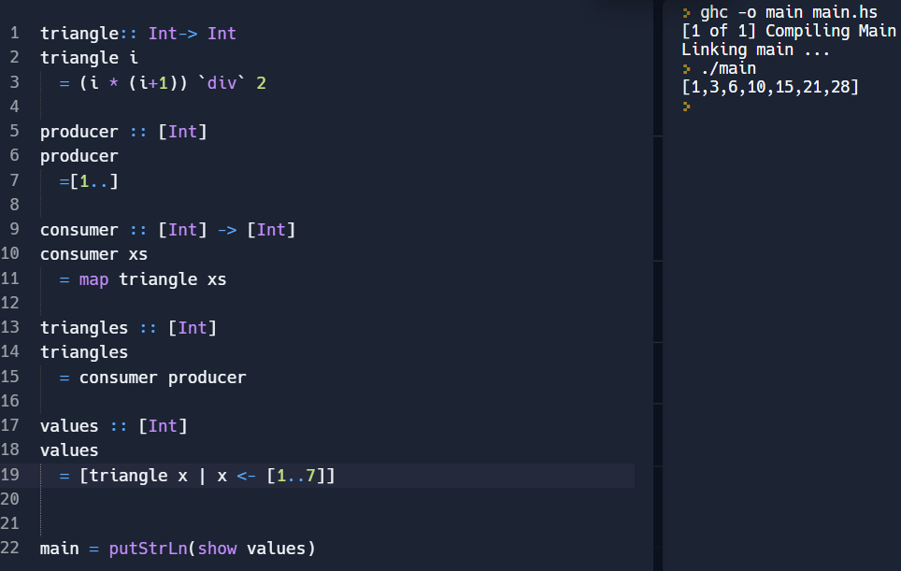

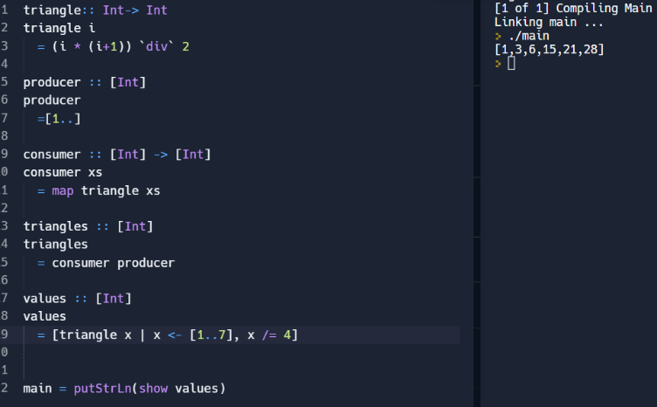

L1

Inputs and Outputs

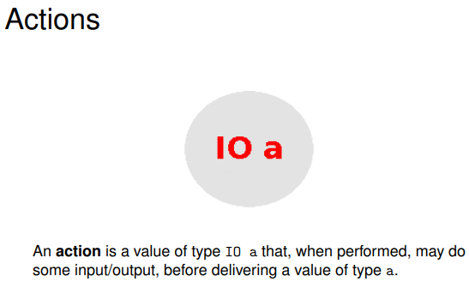

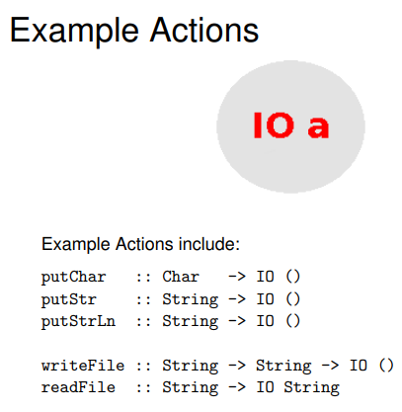

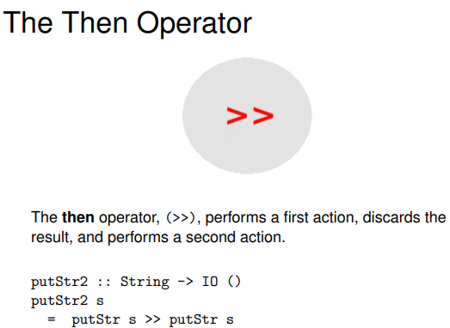

It constrains the way you combine IO operations

(>>) :: IO a -> b…………………

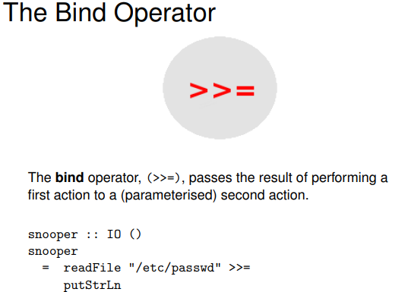

Thi9s lets you pass on a result of one IO operation to another

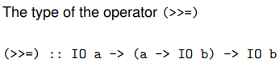

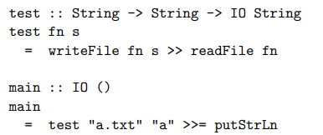

Fn is a filename

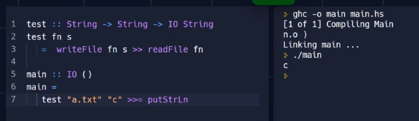

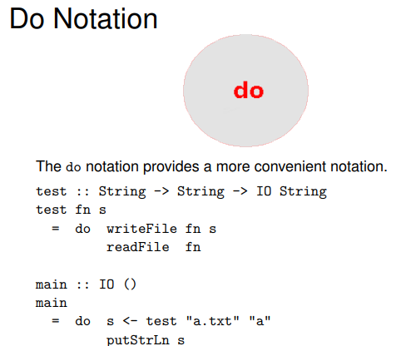

You can have multiple IO operations with do

If you write do block with various statements then you are misusing haskell

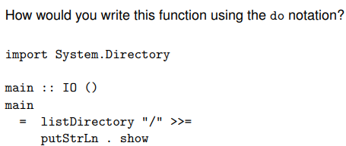

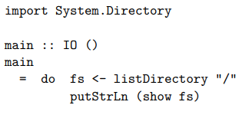

L2

Lambda Calculus

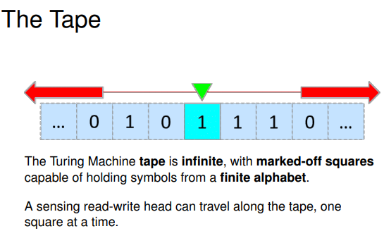

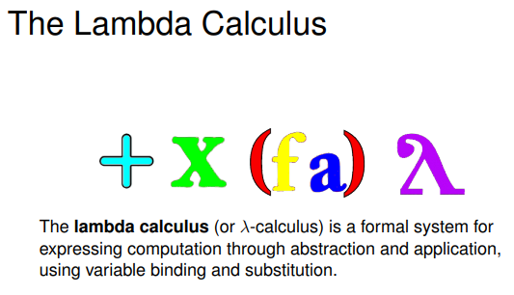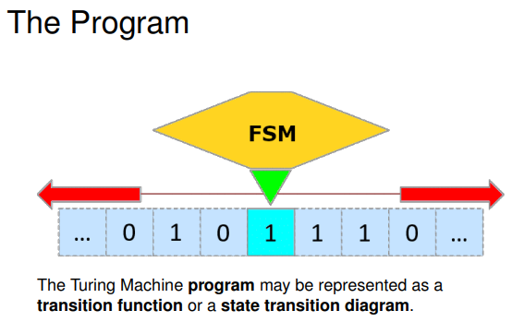

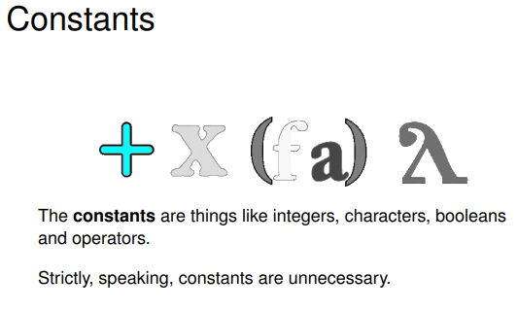

Variable

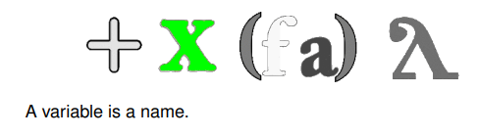

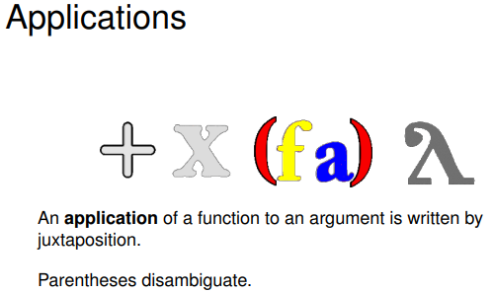

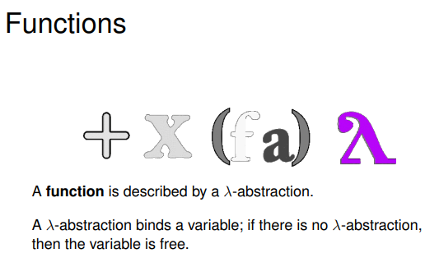

Functional programming languages include ML, Miranda, Haskell, OCAML, . . .

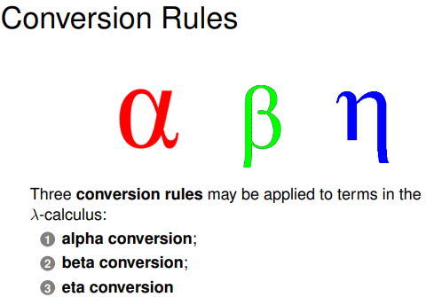

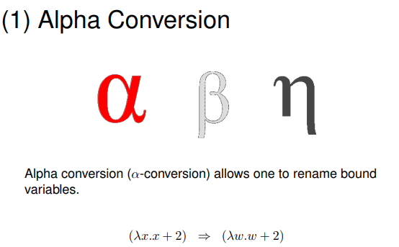

Alpha conversion renames variables and variables must be renamed consistently

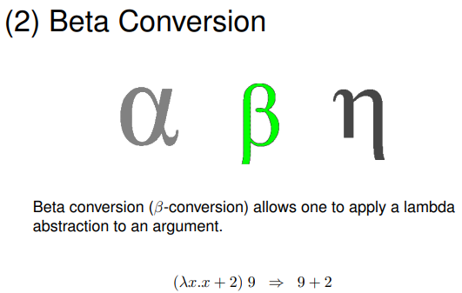

Beta function is function application

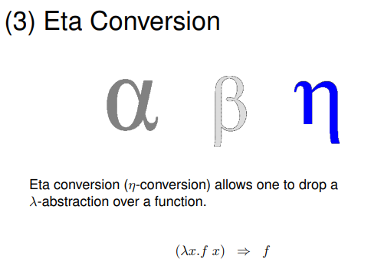

g(x)= f(x) means they must be the same function

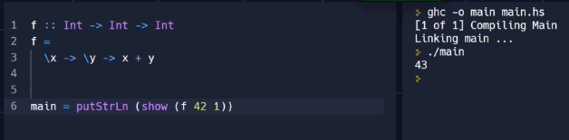

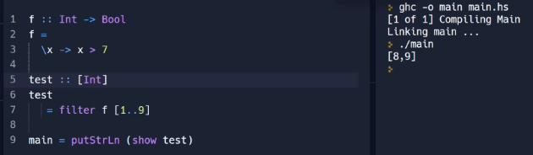

Week 5

Practical

Activity 1

seqmax- sequential maximum function

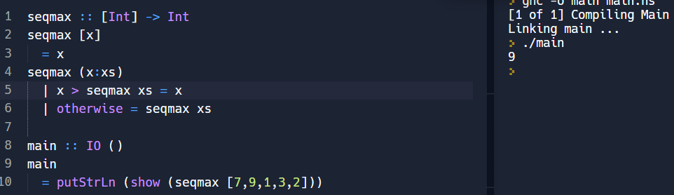

Activity 2

dcmax – divide and conquer maximum function

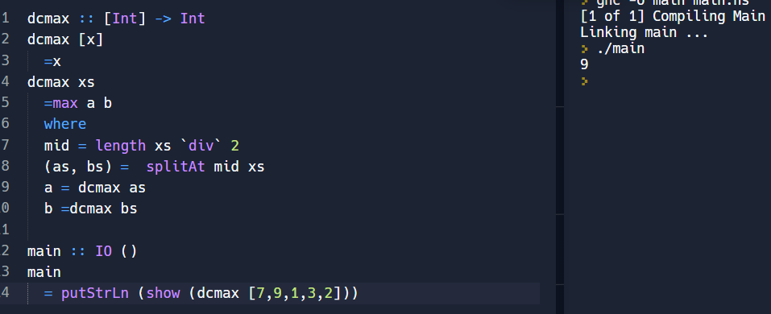

Activity 4

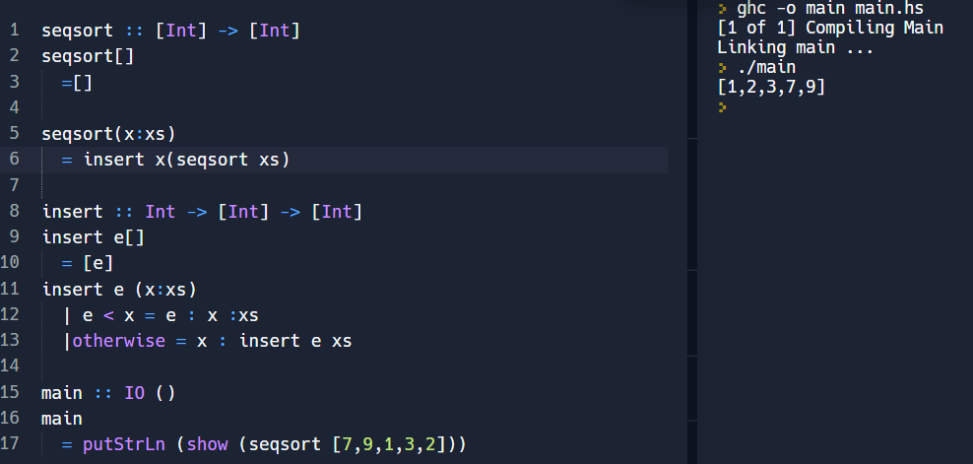seqsort- sequential sort

Activity 5

partition

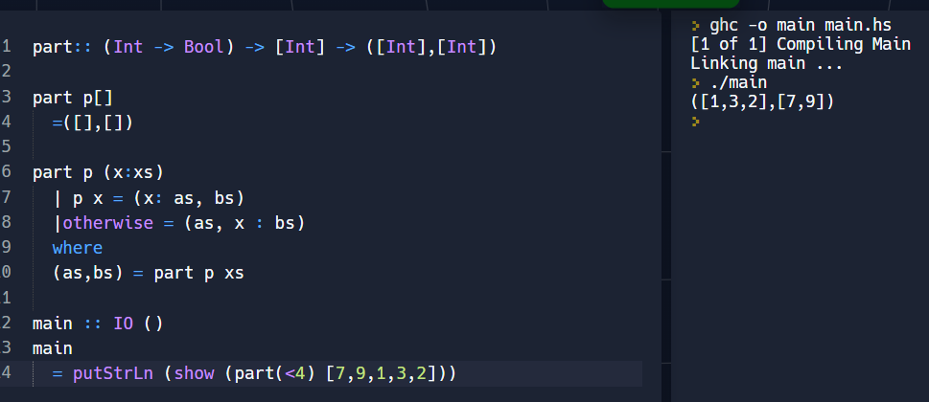

Activity 6

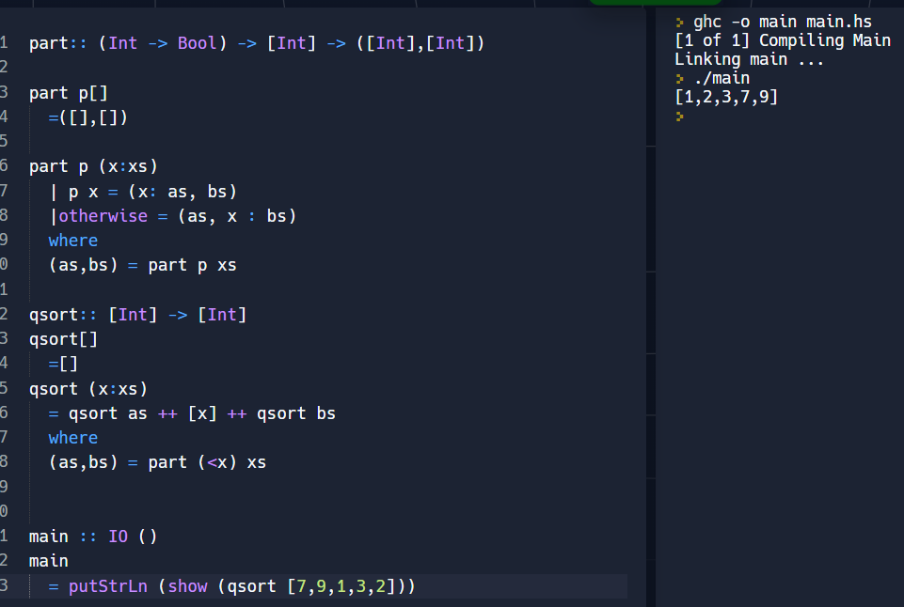

Quicksort should not be used on small data

When you do par y you thread out the element of x and get back y

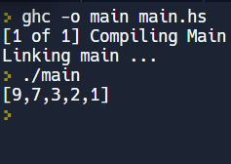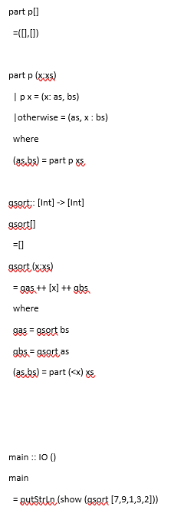

L1

Parallel functioning programming

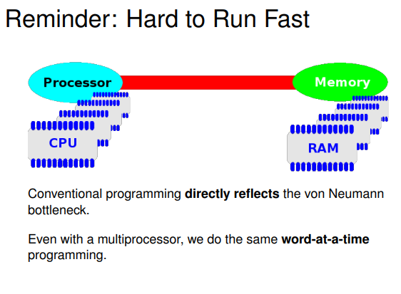

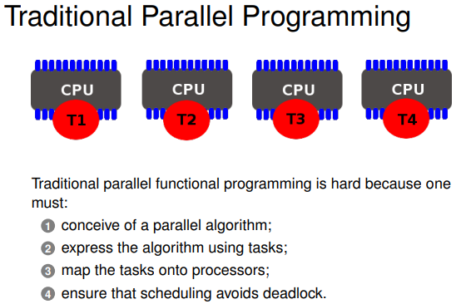

You can’t do parallel programming without a parallel algorithm

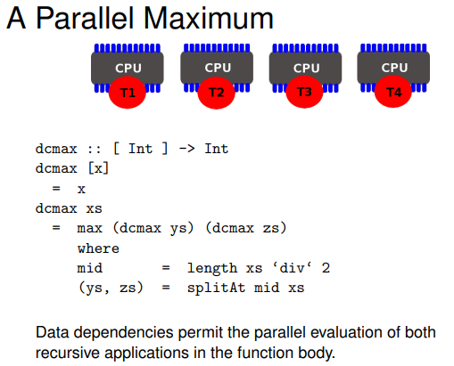

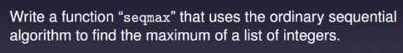

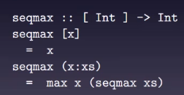

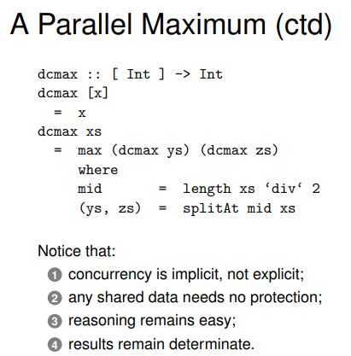

There is div in mid as you want even split in your processors

1 means there is parallelism there but there is not indication of it

2 any shared data needs no protection because you can’t update value of the functional program

3 Reasoning remains easy as it is clear hat that thing does

4 Result remain determinant and that is a key property of parallel programme. So every time you run it you get the same answer

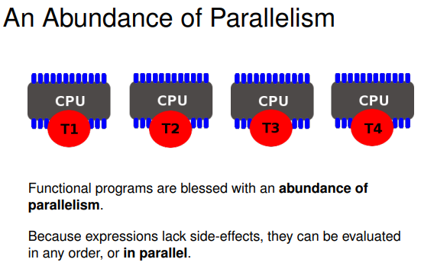

Difficulty with functional programming is that everything can be done in parallel

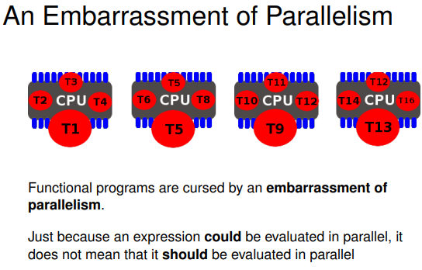

There are 4 processors so it can do four things at once

Once the four tasks are running everything else is queuing waiting for a go on the processor

The difficulty of functional programming isn’t finding parallelism as there is lots of it. The problem is how you choose the useful parallelism from the stuff that isn’t

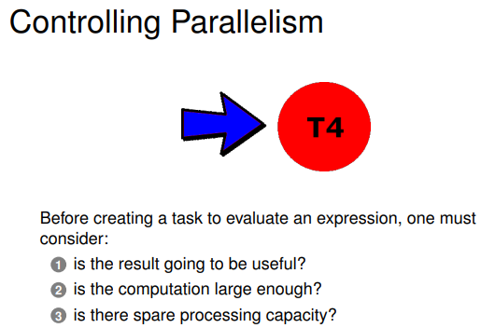

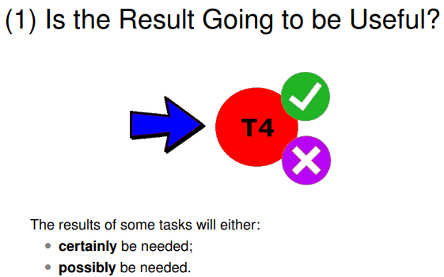

With a conditional of a true branch and false branch, only one thing is going to be taken according to whether the condition is true

Once the condition is known, then one branch is already evaluated

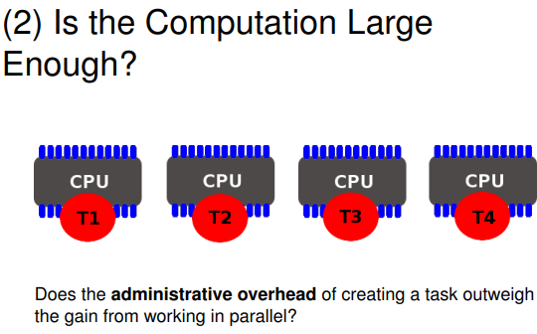

By this it means there are lot of overhead for setting up a parallel task

You have to decide if a particular task is worth it and that decision maybe trivial or not rivial

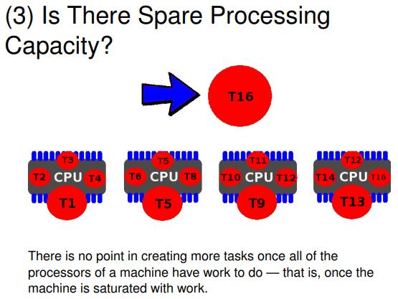

If every processor is doing something useful there is not point of giving it more work

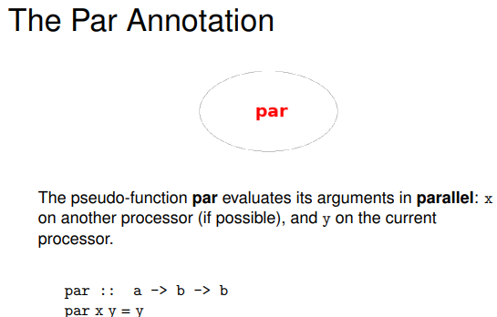

Par takes two arguments and returns the second

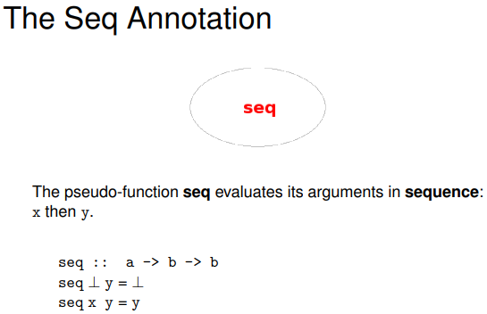

Upside down T – is a bottom element of a domain

The upside down T is saying seq will evaluate its first argument and return in second

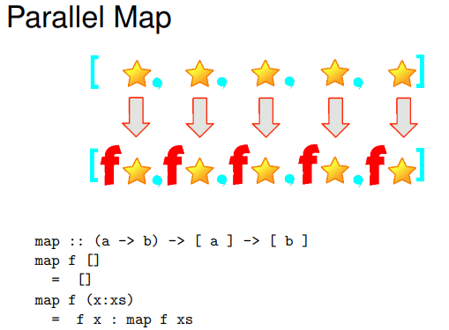

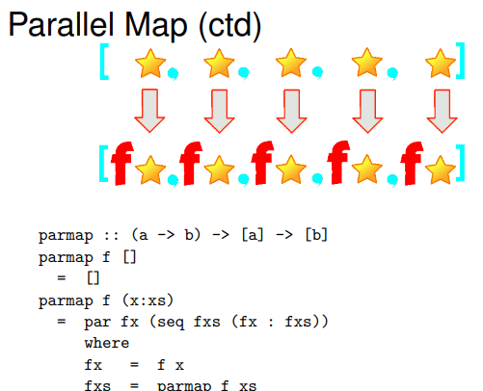

Par fx says launch a thread to evaluate fx

The seq is saying push the recursive call of parmap fxs urgently and don’t wait for lazy evaluator to demand the rest of the list

Evaluatin will be fx in parallel

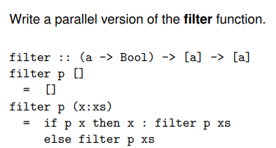

Filter goes through the list and applies predicate function hich decides if the elemnt makes it into the result list or not

With parallel you can apply predicate to every element of the list

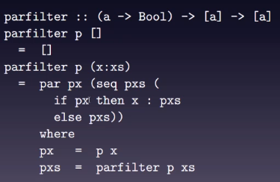

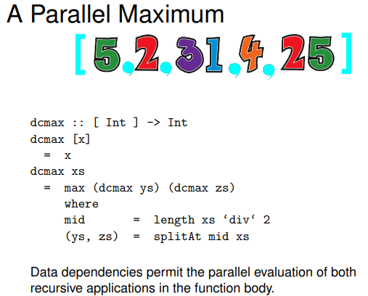

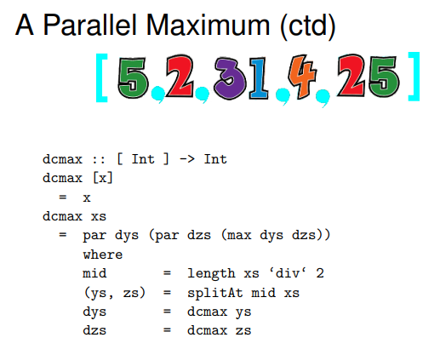

I don’t have to use seq in this as there is no laziness

Seq is necessary in lazy data structures with map and filter

Although you force down par on both sides of maximum, this cant be done in practise because that will leave one task waiting for two others

This function has only par which says one side of max will be launched and others will be done by itself otherwise it will be a waste of threads just waiting for two tasks

L2

The Tomorrow World

No one uses Haskell….

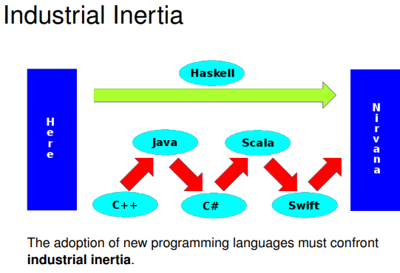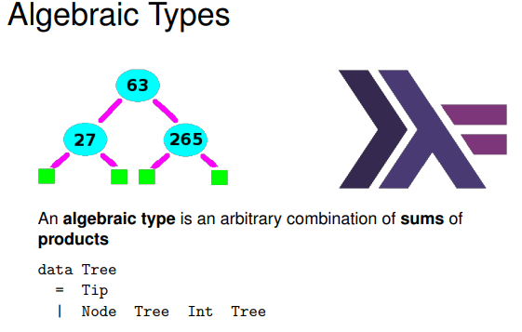

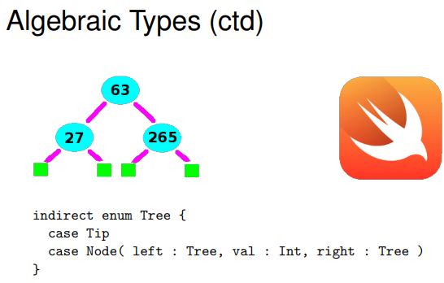

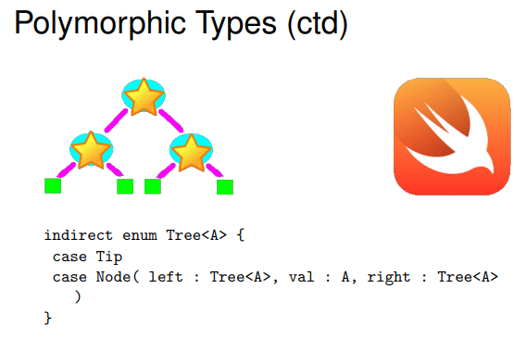

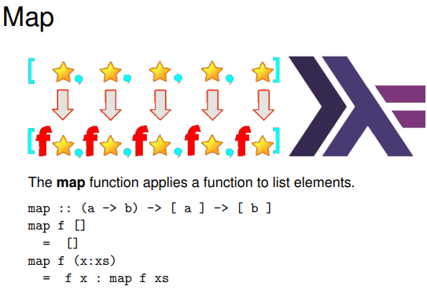

It is higher order as it takes a function as an argument

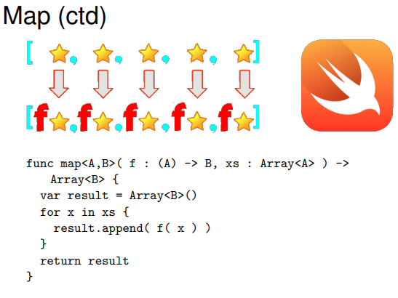

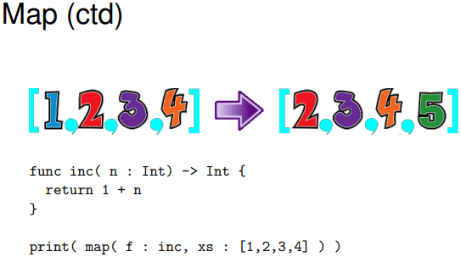

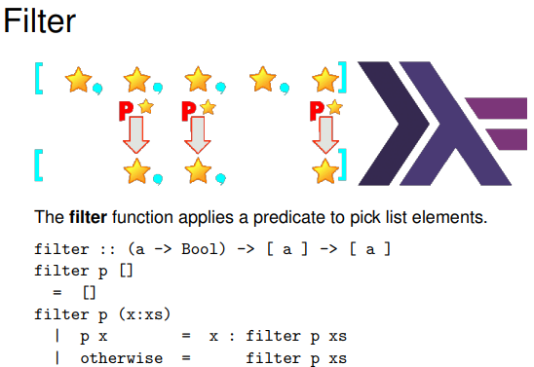

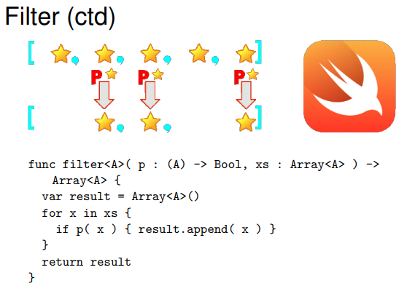

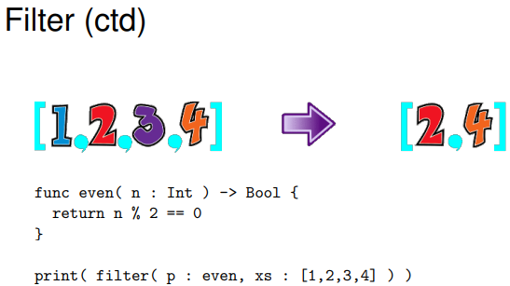

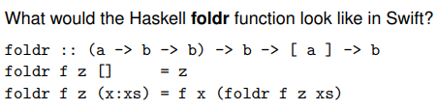

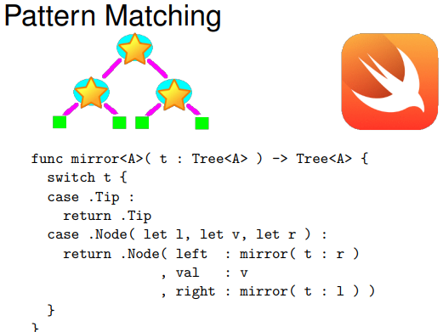

‘let’ allows you to name things

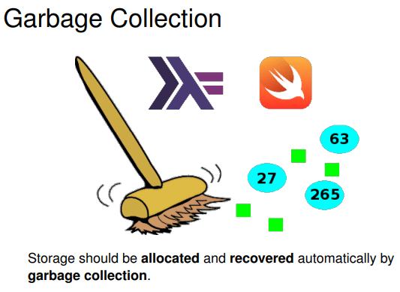

In some programming language you allocate storage yourself

If you run out of memory the garbage collection gets rid of the unused memory then you allocate the memory

Week 7

Practical

Logic Programming

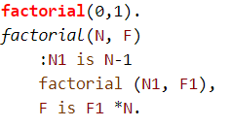

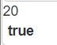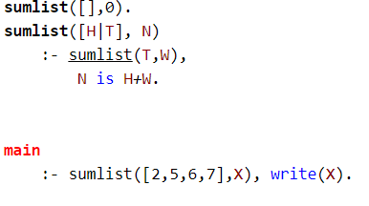

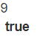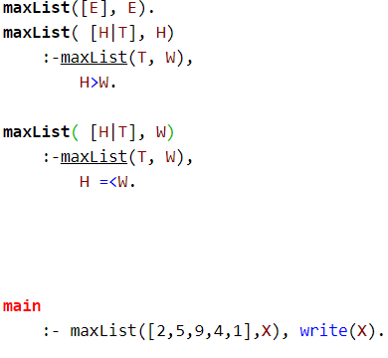

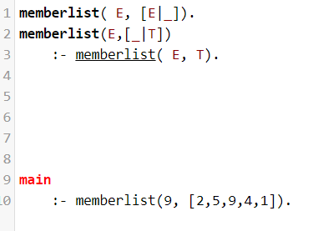

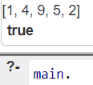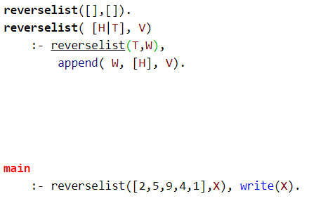

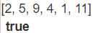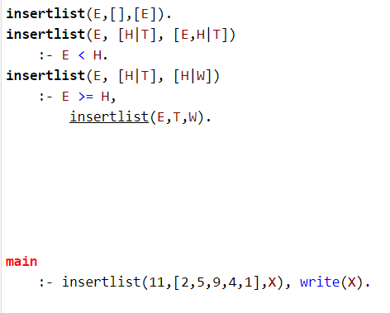

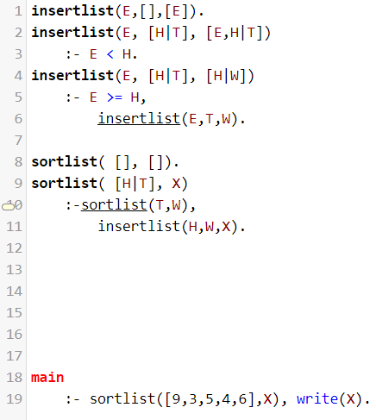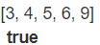

Week 7

L1

Software Crisis

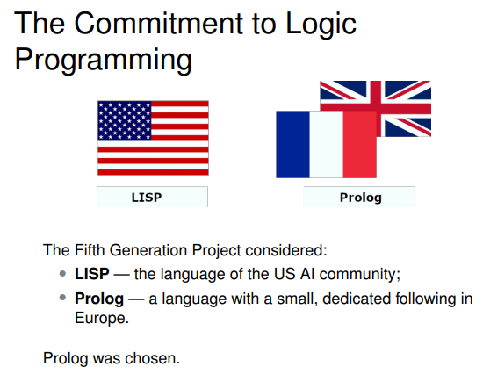

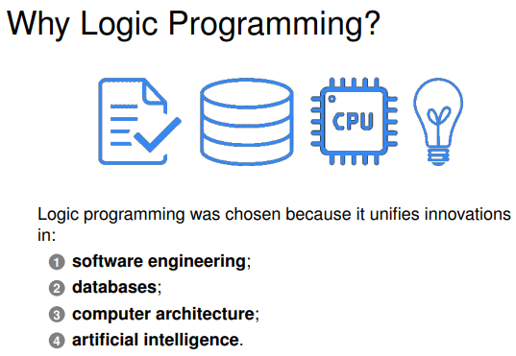

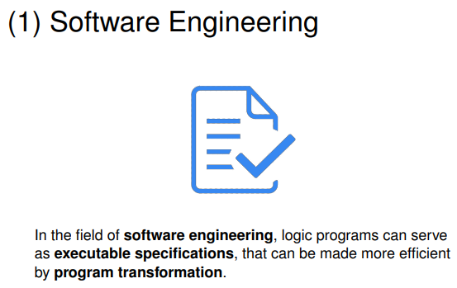

Problem with software engineering is translating specifications into executable programs so it is hard for a user to describe what they want the computer program to do

If you use natural language things can fall apart

Prolog is better as there is no specification and implementation, you would write your specification in logical clauses which is prolog

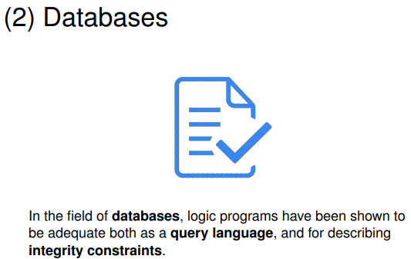

Prolog talks to the database directly

As prolog is a logic language you can get nice logical queries across databases

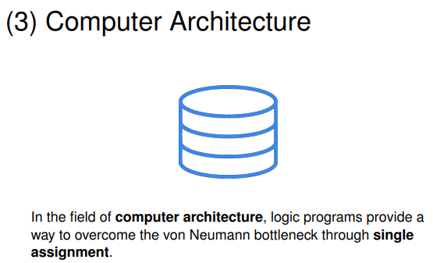

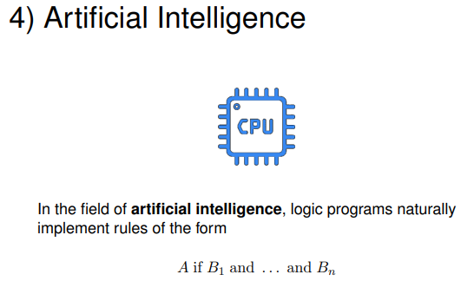

L2

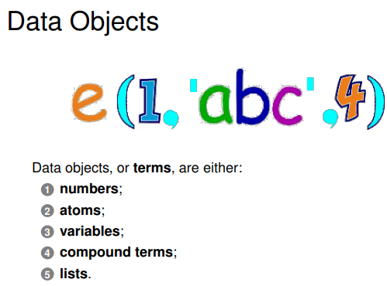

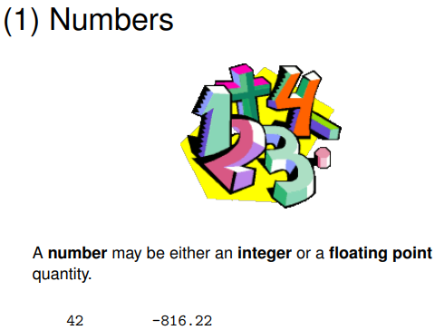

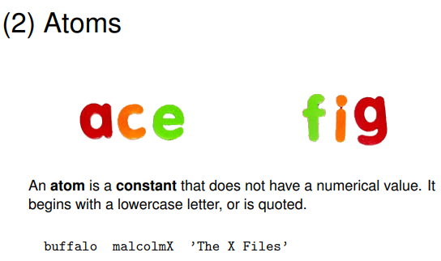

Prlog variables start with uppercase and data types are lower case

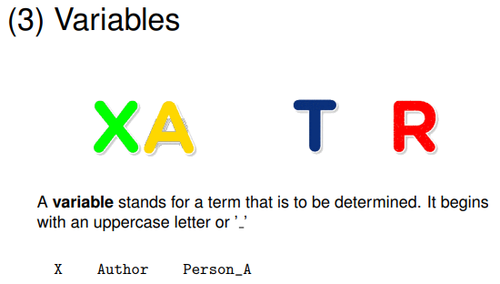

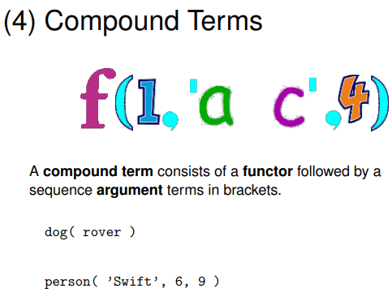

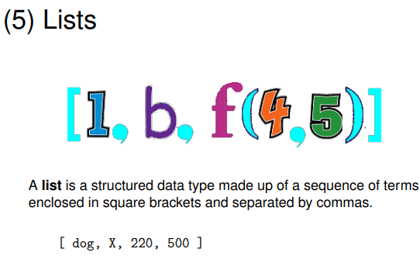

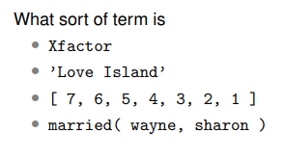

Xfactor is varaible

“Love Island” is an atom

3 is list

Compound term

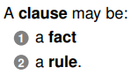

Facts

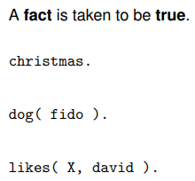 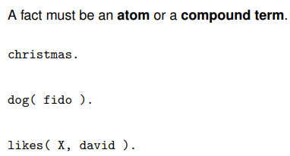

Rules

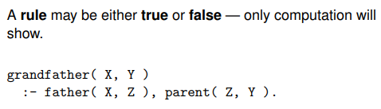

Rules are used to do things like computation

Grandfather X,Y is true if these things that follow are all true together, so they’re conjunctions

Grandfather(X,Y) is true if father(X,Z) is a parent Y and those things must be true together

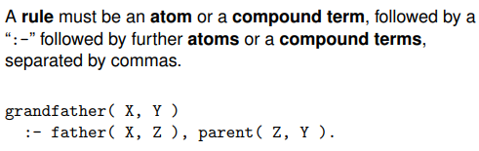

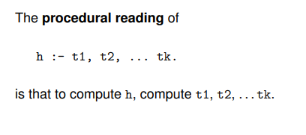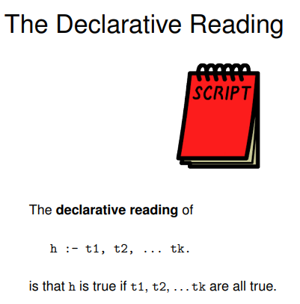



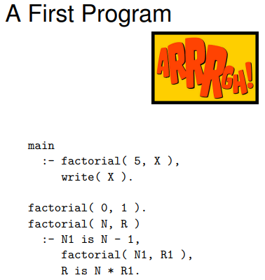

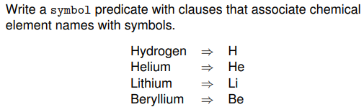

Overloading

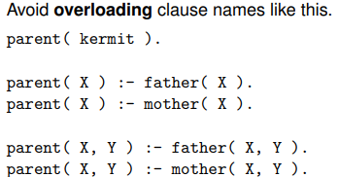

Predicates

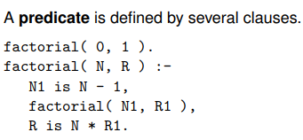

Week 8

Practical

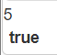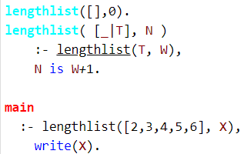

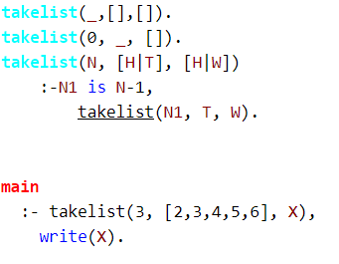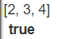

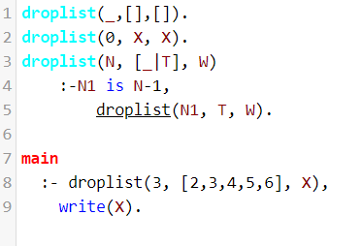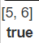

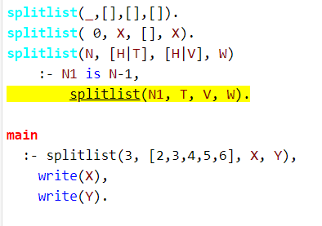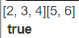

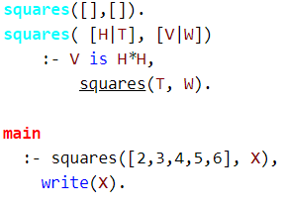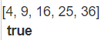

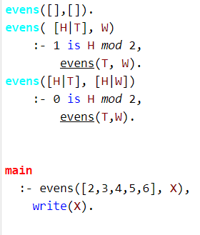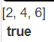

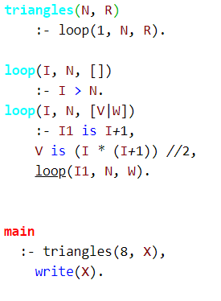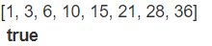

L1

Satisfying Goals

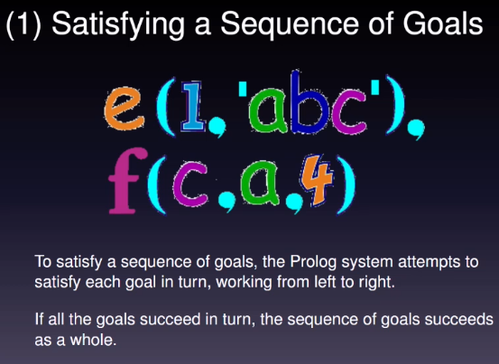

Prologs and is asymmetric

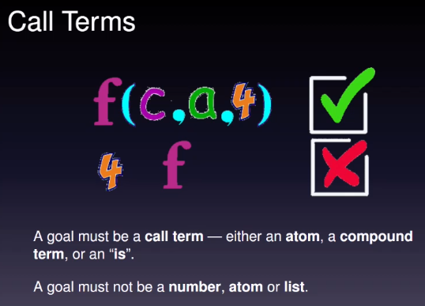

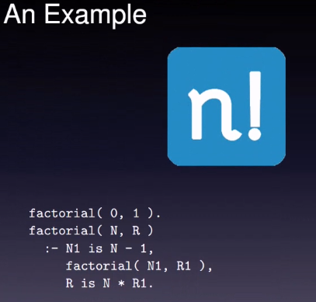

factorial(0,1) is an axiomatic fact

factorial of N1 is N-1 and this is going to be true, but binding of N1 is N-1

The order of these things matter so when N1 introduces a new variable, so that you can use it in a recursive call

If you swap the order of the recursive calls, logically it should not make any difference because it’s a condition

But for the left to right evaluation you can’t use N1 until you have defined it

If you put the first factorial clause(factorial(0,1)) after second one then things will go wrong as it will recurse infinitely

Order matters hen you write predicates

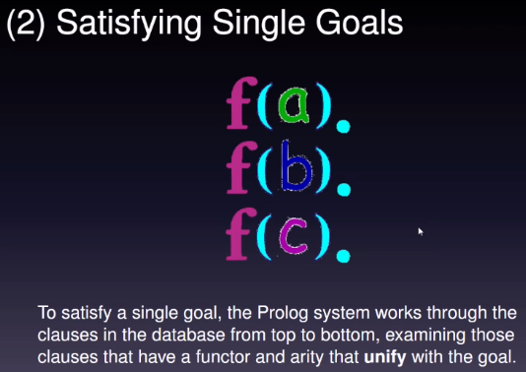

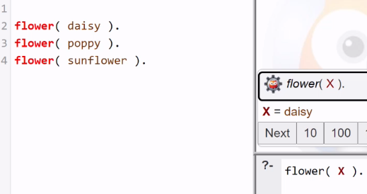

It says daisy as it is the first one

Click next to get poppy and sunflower

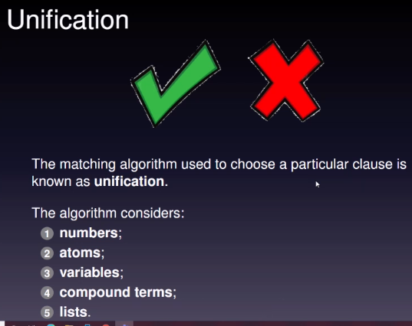

It can unify one term to another

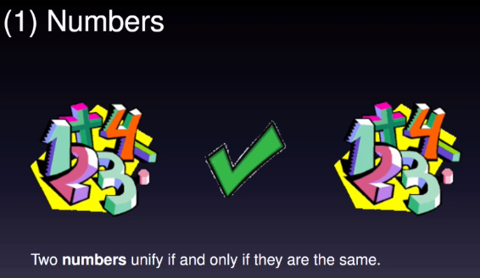

E.g. unification of 42 and 7 does not work

but unification of 42 and 42 works

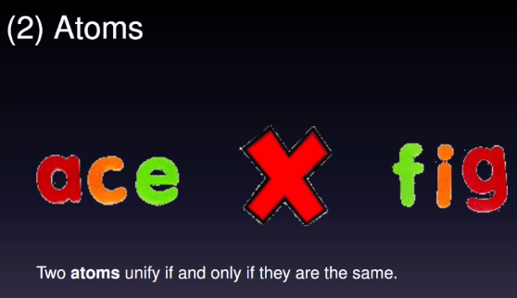

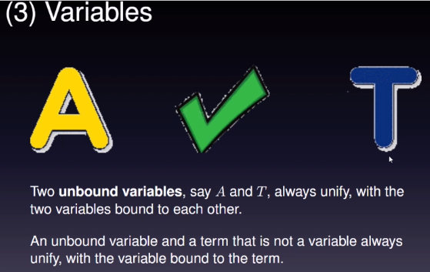

Variables can unify with anything

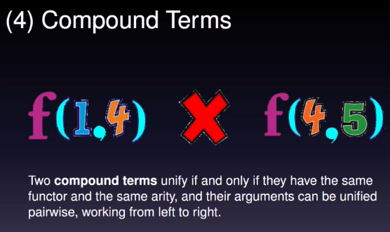

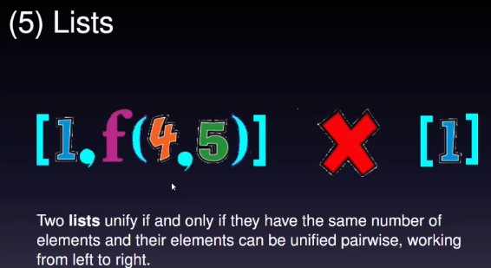

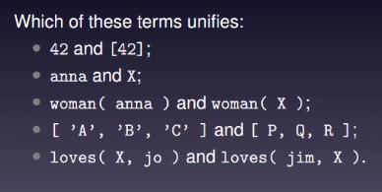

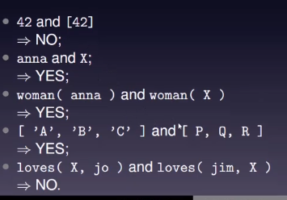

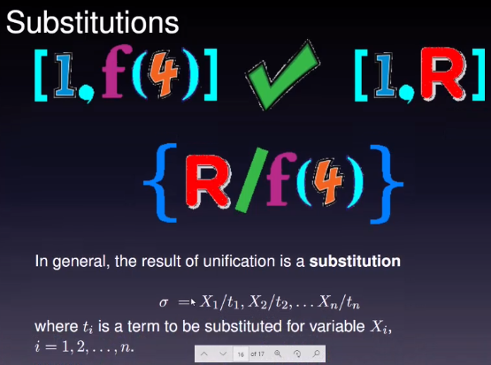

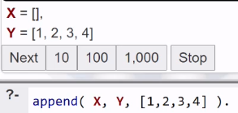

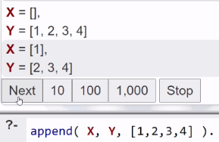

The prolog engine does all the proof engines for you as it is built in and functional programming does not do anything like that

L2

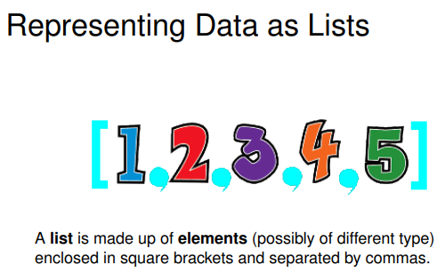

Difference between Prolog and Haskell list

In haskell everything in the list is of the same type and Prolog lists are not

So any term can go in a prolog list

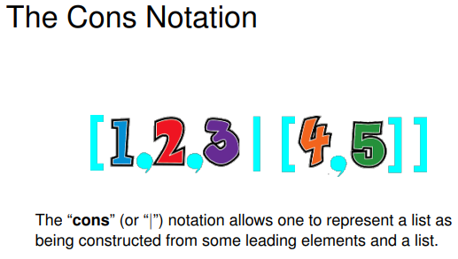

If I simply the list at the end it would be [1,2,3,4,5]

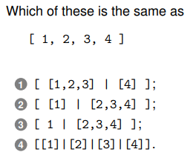

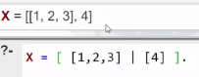

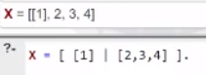

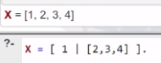

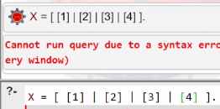

It is syntactically incorrect as there should be one vertical bar

1. No
2. No
3. Yes
4. No

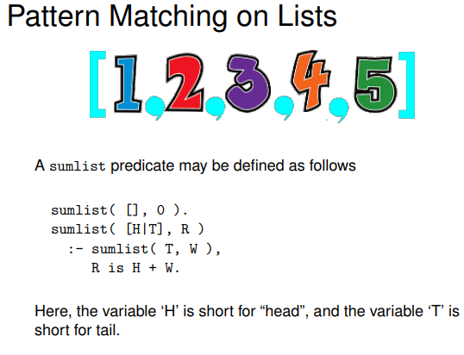

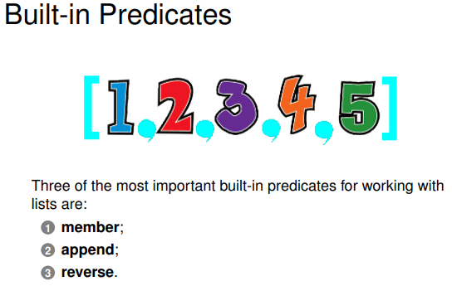

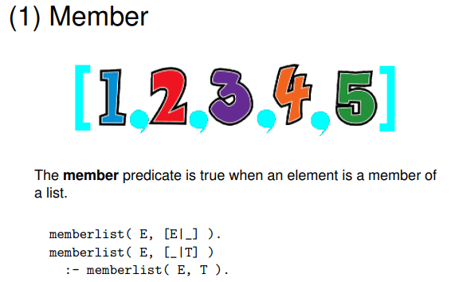

1st line says if you are looking for an element and it is at the head of the list then that is true

2nd line says otherwise look in the tail

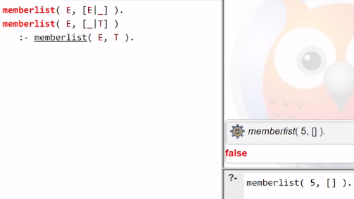

Closed world assumption says if it is stated it true otherwise it is false

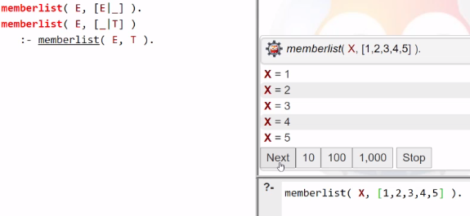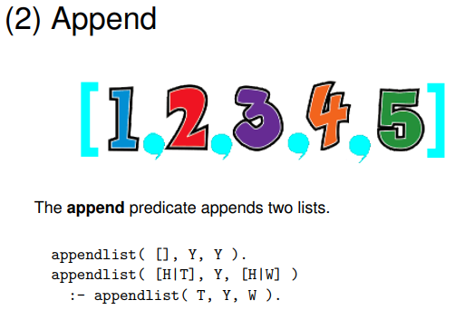

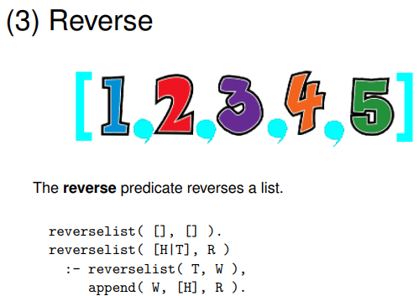

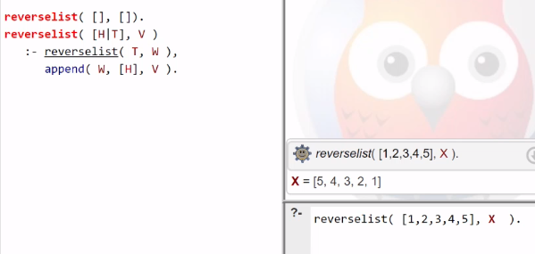

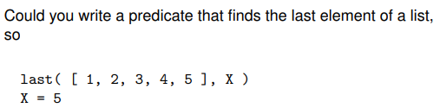

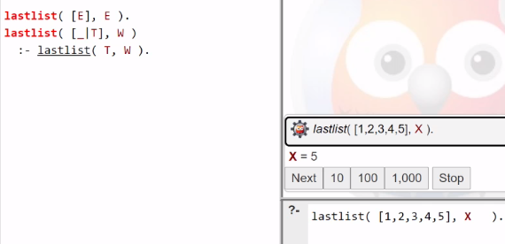

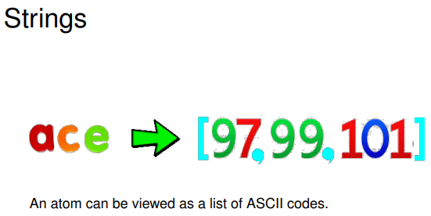

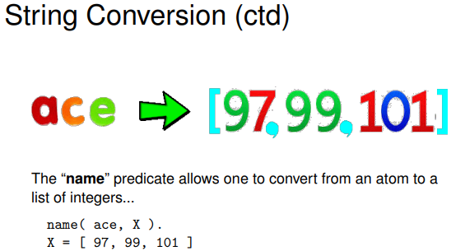

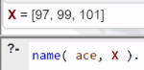

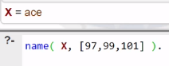

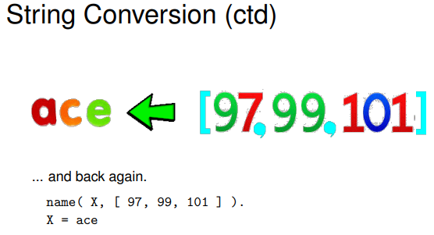

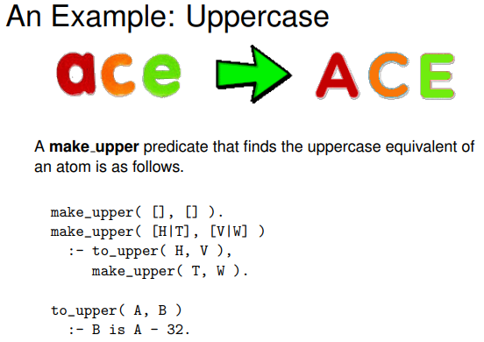

Converts an atom to an uppercase

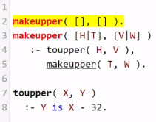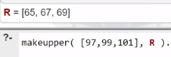

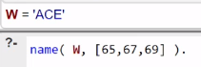

Prolog can do string processing

Week 9

Practical

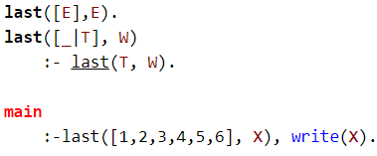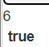

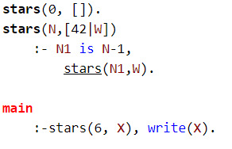

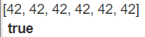

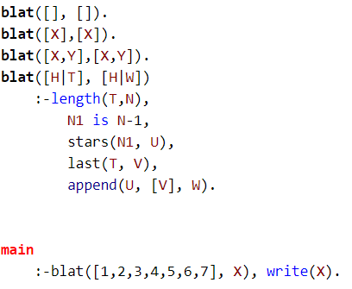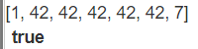

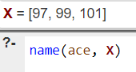

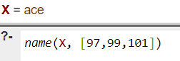

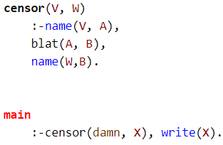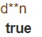

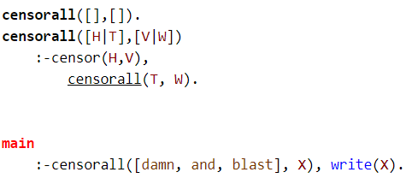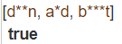

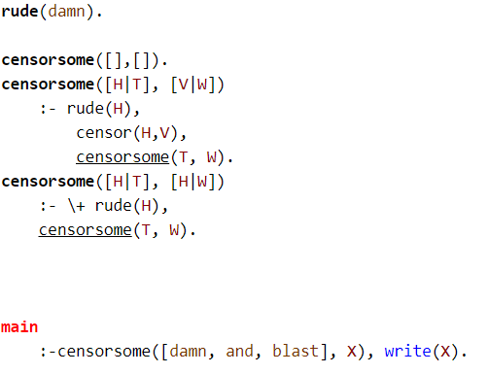

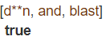  
  
Week 9

L1

Numbers and Operators

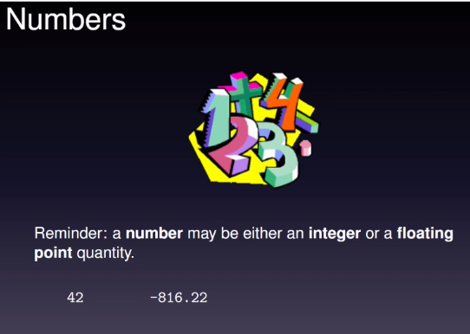

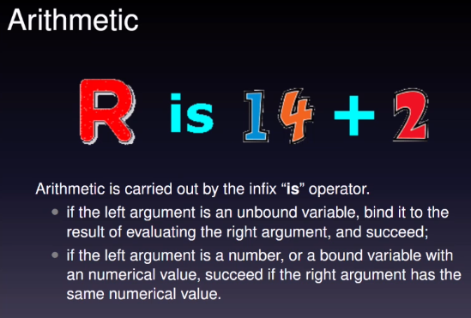

‘is’ is normally replaced with equals

‘equals’ is the unification operation for Prolog and this is why ‘is’ is used

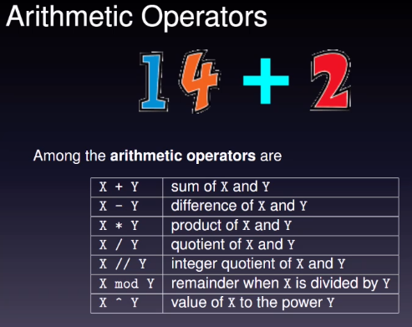

e.g.

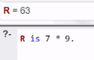

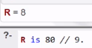 8x9=72

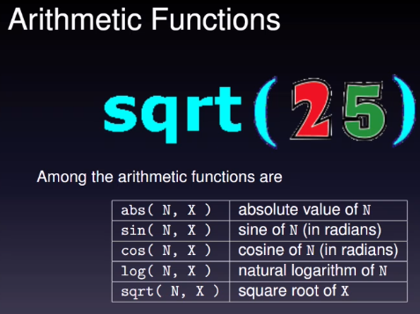

e.g.

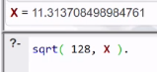

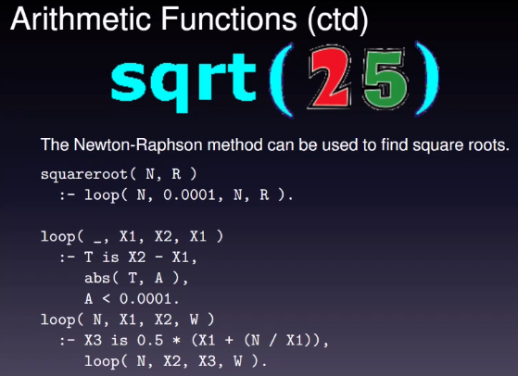

N is something we are going to take the square root of and R is the result

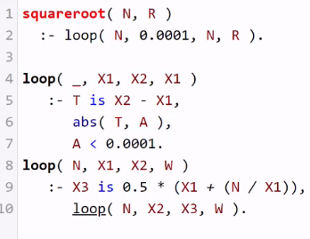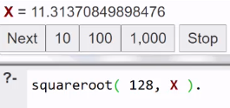

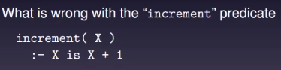

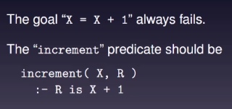

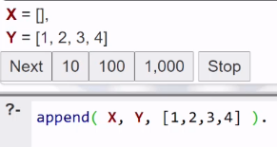

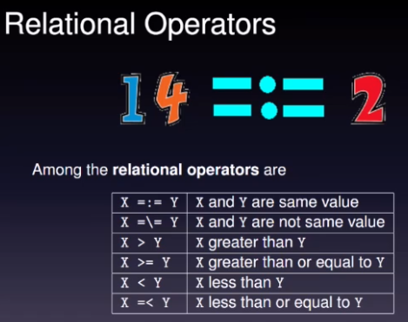

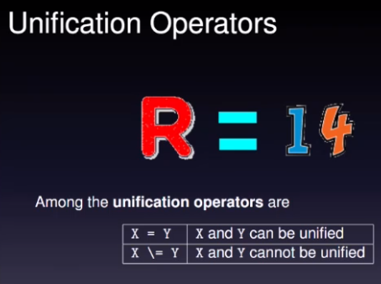

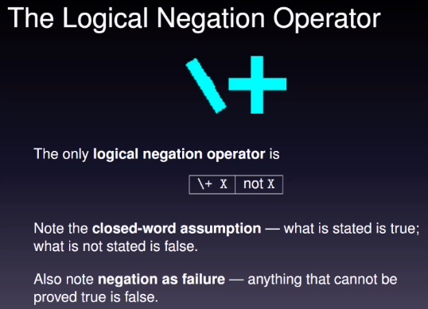

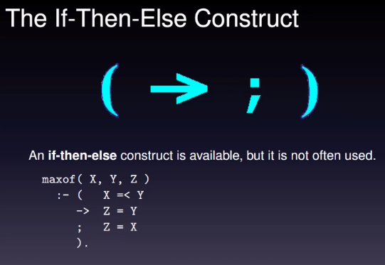

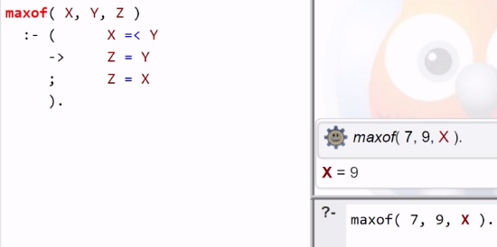

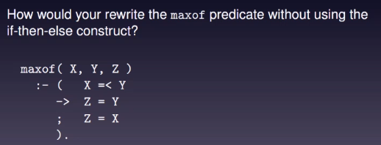

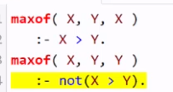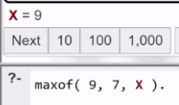

L2

Input/ Output

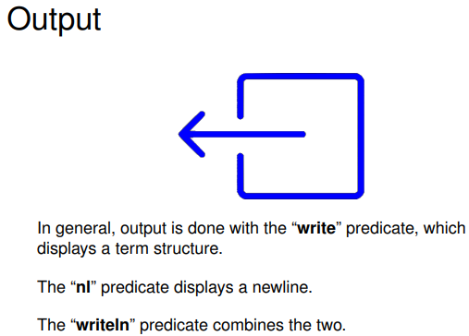

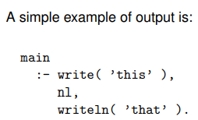

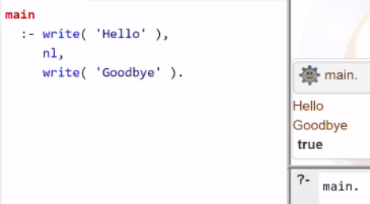

Input

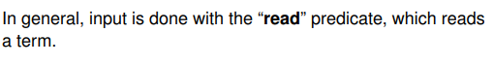

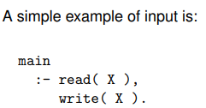

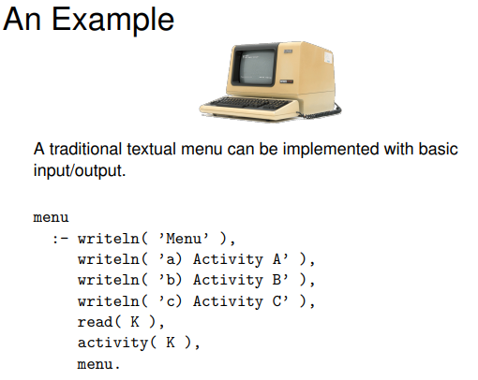

When you read it should be a prolog term, it should be one of A, B, C

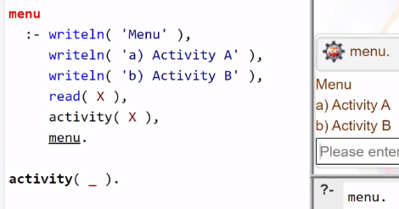

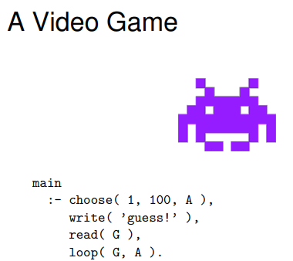

Computer chooses the number between 1 and 100

Write users guess

Then read their guess

….

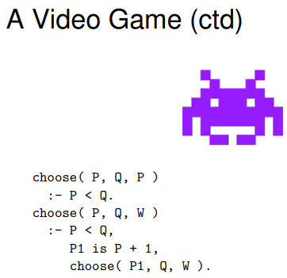

Choose is implemented

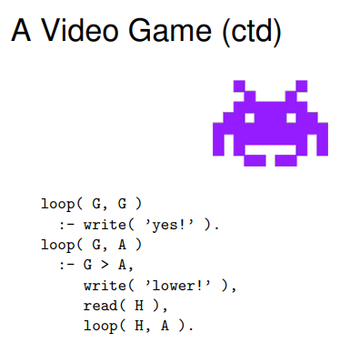

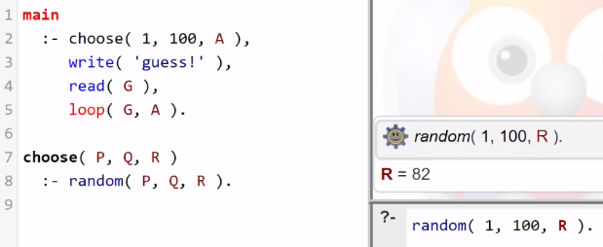

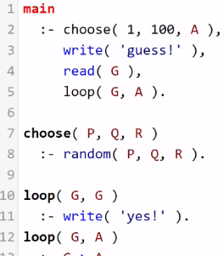

Week 10

L1

Changing the Database

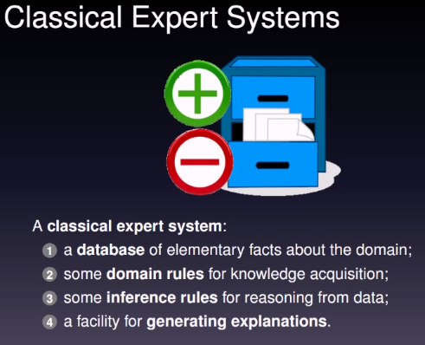

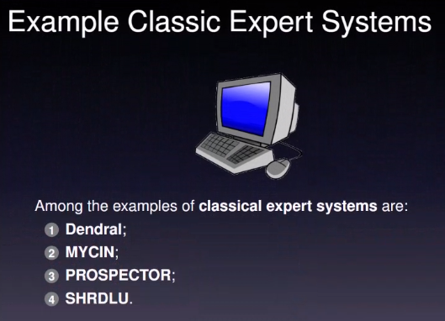

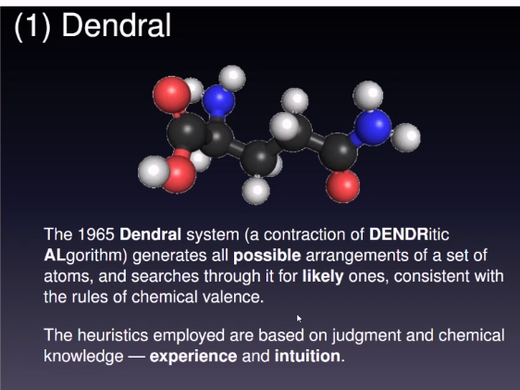

Its for modelling chemical compounds



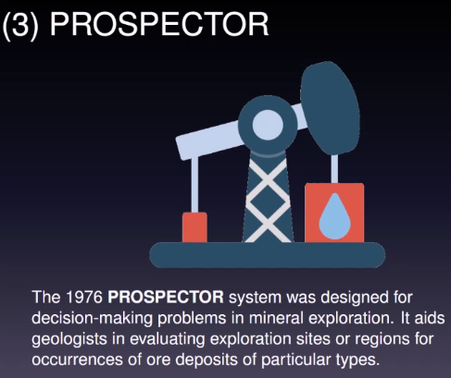

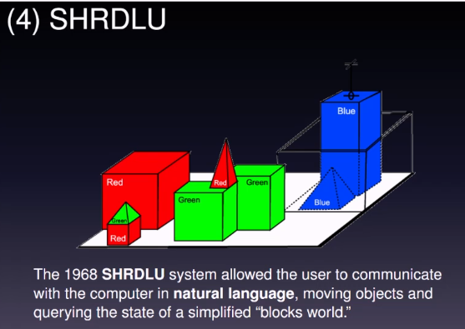

Its idea is to parse sentences

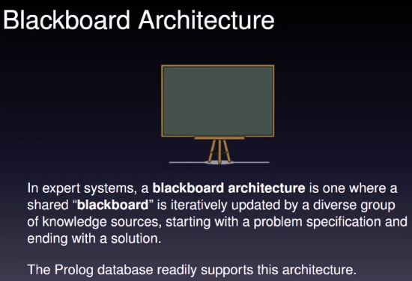

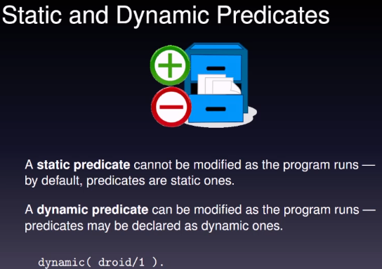

/1 indicates the number of arguments the predicates have

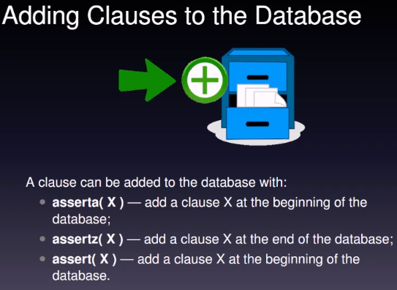

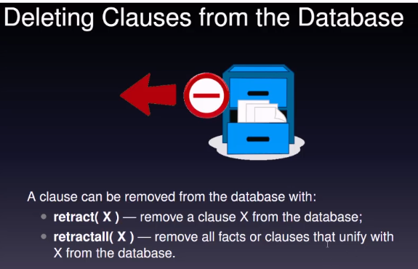

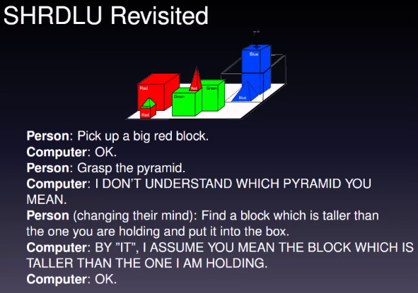

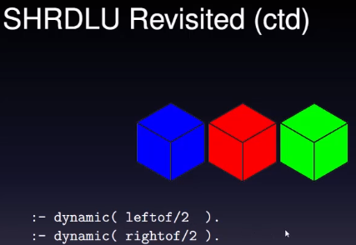

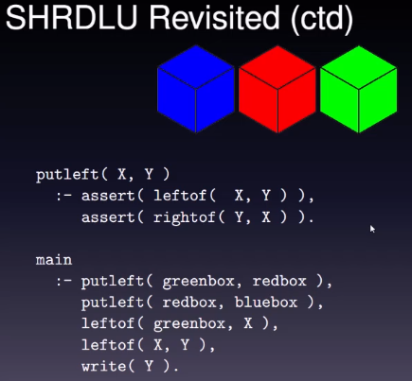

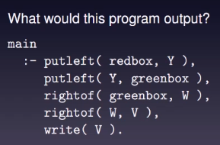

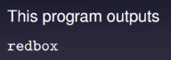

L2

Parallel Logic Programming

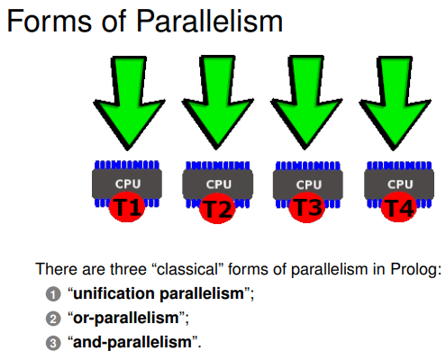

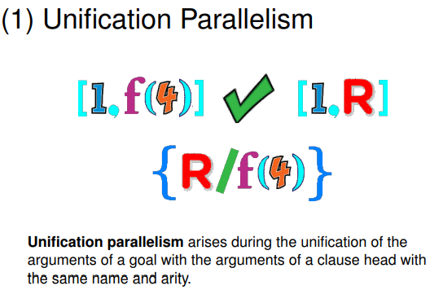

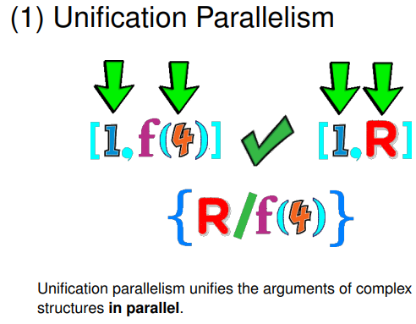

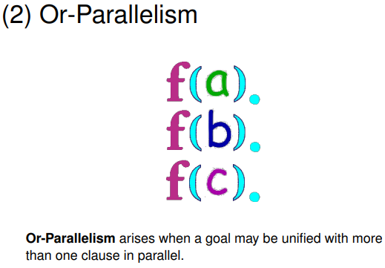

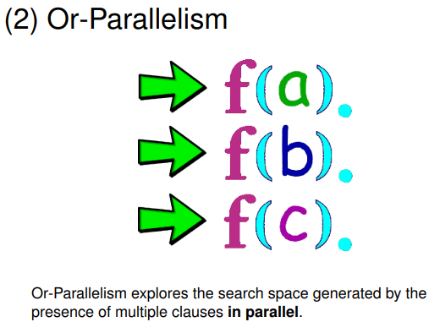



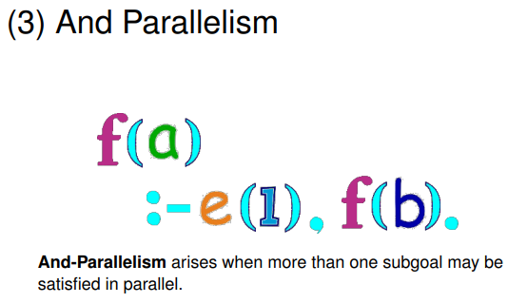

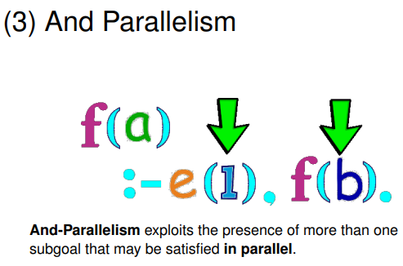



Week 10

Finite State Automata

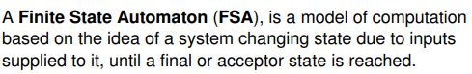

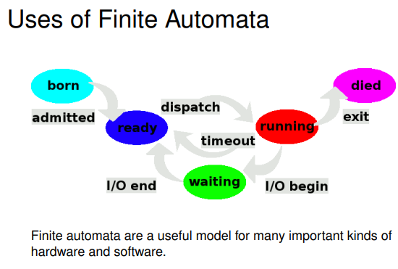

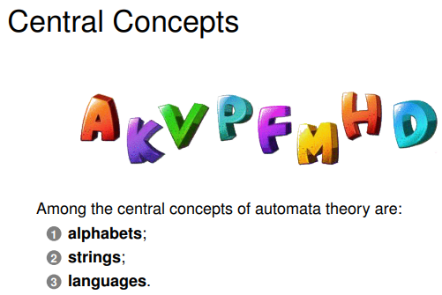

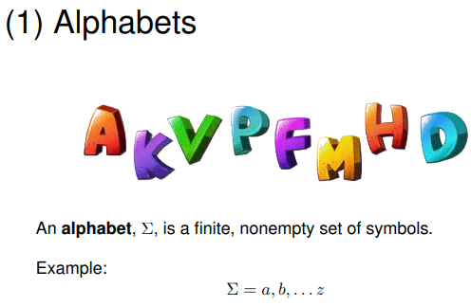

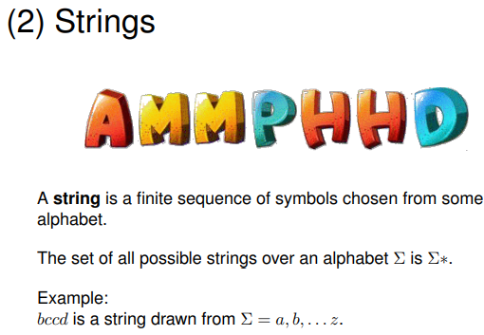

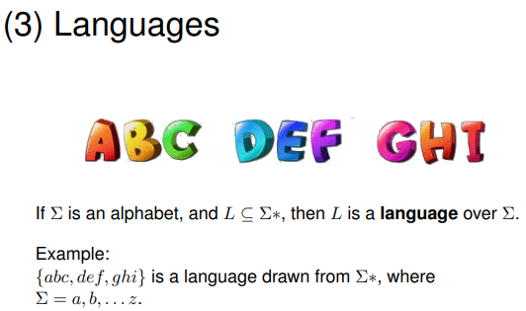

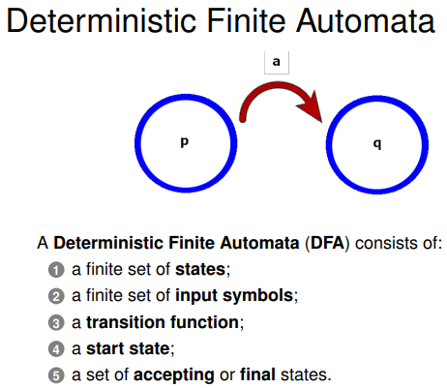

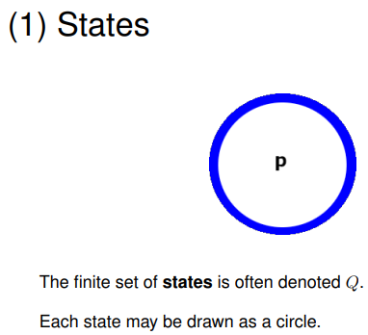

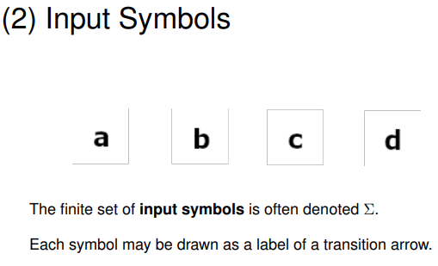

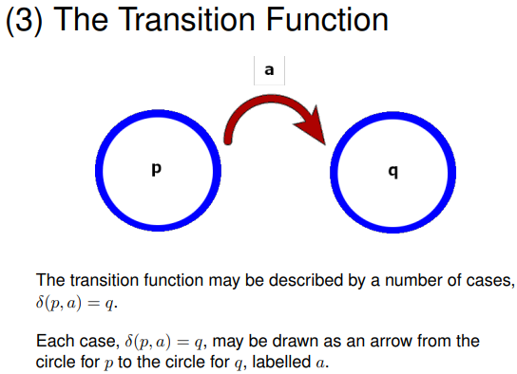

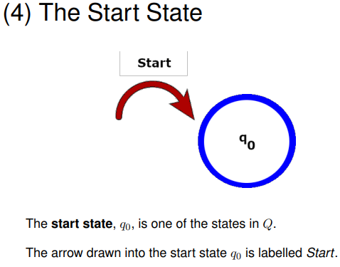

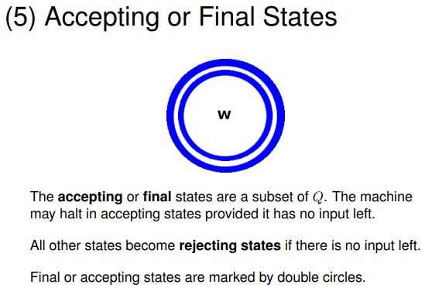

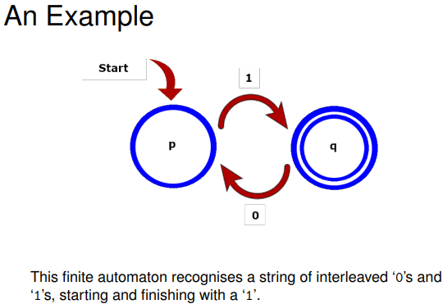

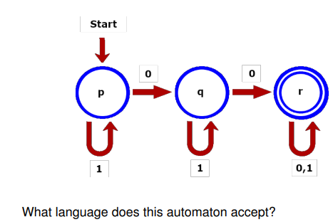

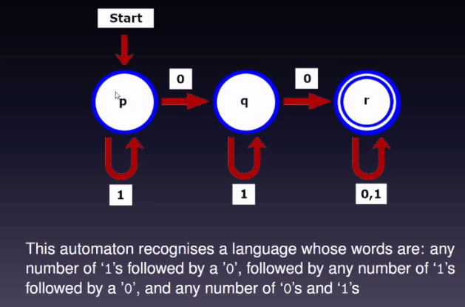

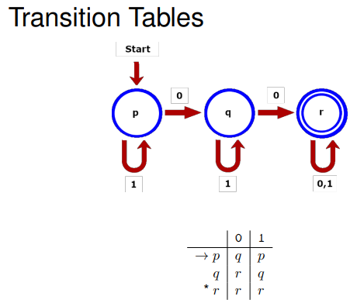

The table is much more compact and it is processed by machine

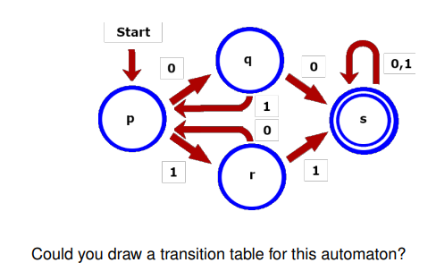

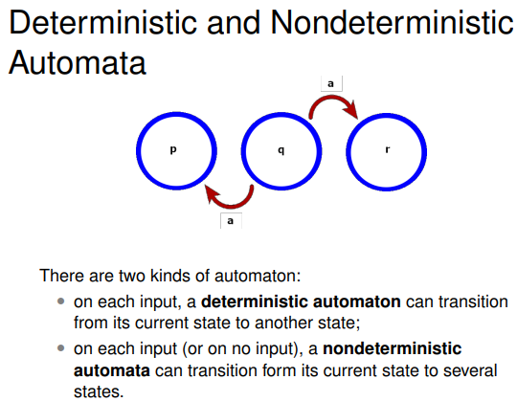

L2

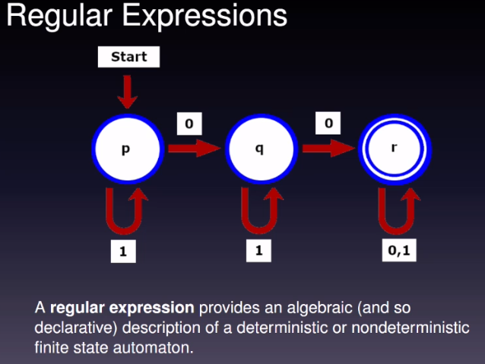

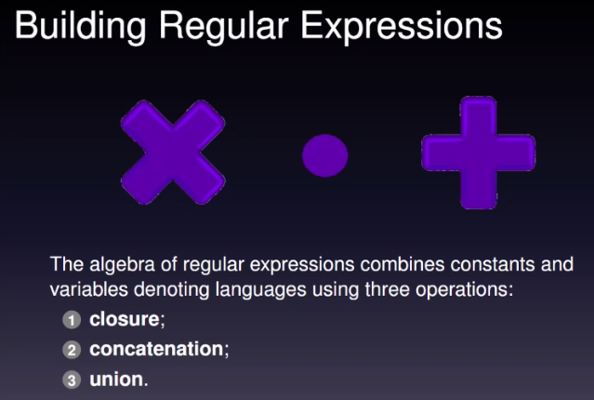

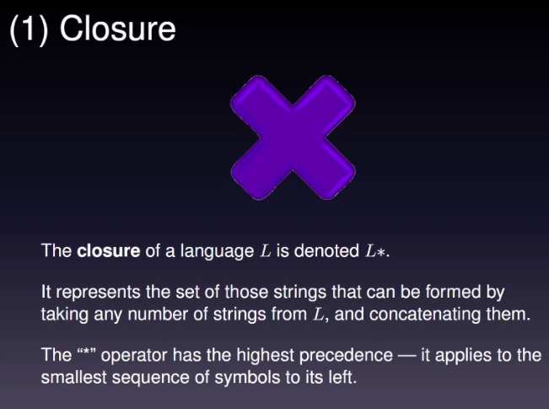

X sign is high precedence

If you have 1 immediately followed by a star that is known as a closure operator

1 x

This is zero or more ones in a row

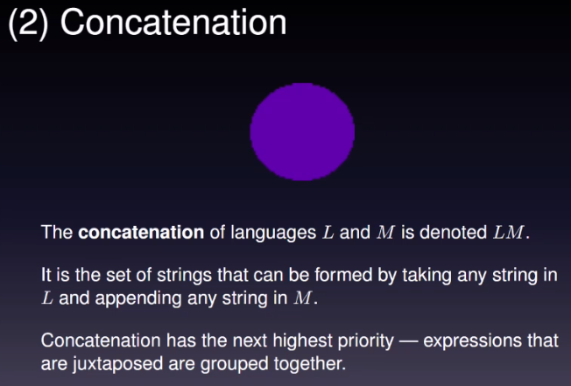

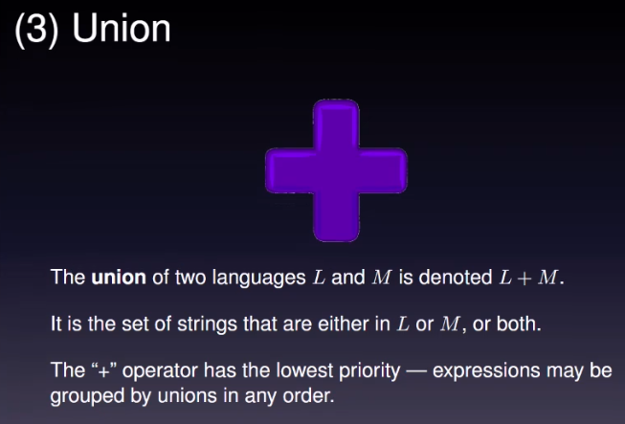

+ has low priority so you can write AB + CD

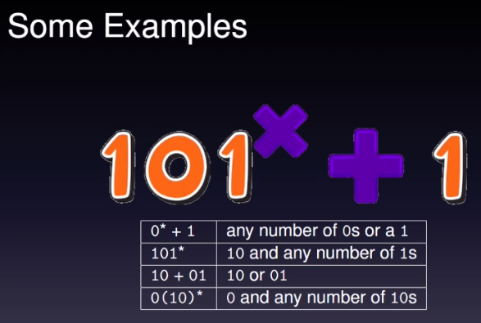

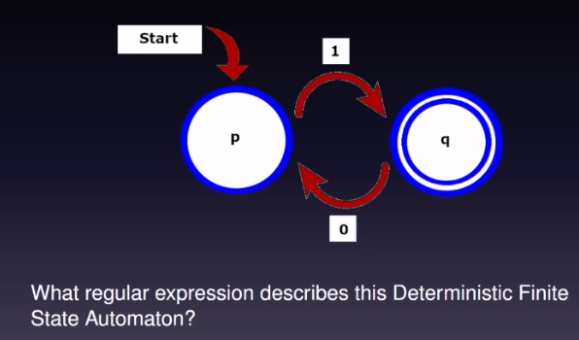

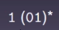

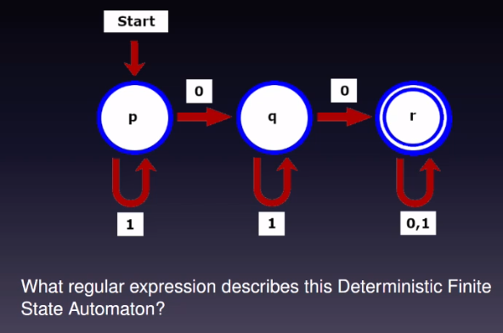

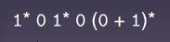

Prolog Singleton variable when a variable has been only used once in the entire program

Q3 backup

%Begin Q3.1

index([A|_],0,A).

index([_|B],X,Y):-

index(B, J, Y),

X is J + 1.

indices([],_,[]).

indices([A|AS],C,[B|BS]):-

index(C,A,B),

indices(AS,C,BS).

%End Q3.1

%Begin Q3.2

possible(GRID):-

length(GRID, 9),

indices(_,GRID,[1,2,3,4,5,6,7,8,9]).

%End Q3.2

%Begin Q3.3

add([], 0).

add([X|Y], Z):-

add(Y, Z1),

Z is Z1 + X.

acceptable(S1,S2,S3,S4,IA,SA,IB,SB,IC,SC,GRID):-

indices([0,1,3,4],GRID,V1),

add(V1, S1),

indices([1,2,4,5],GRID,V2),

add(V2, S2),

indices([3,4,6,7],GRID,V3),

add(V3, S3),

indices([4,5,7,8],GRID,V4),

add(V4, S4),

indices(IA,GRID,VA),

add(VA, SA),

indices(IB,GRID,VB),

add(VB, SB),

indices(IC,GRID,VC),

add(VC, SC).

suko(S1,S2,S3,S4,IA,SA,IB,SB,IC,SC,GRID):-

possible(GRID),

acceptable(S1,S2,S3,S4,IA,SA,IB,SB,IC,SC,GRID).

%End Q3.3

Q4 backup

range(A,A,[A]).

range(A,B,[A|T]):-

A2 is A+1,

range(A2,B,T).

divisor(N,L):-

N1 is N-1,

range(2,N1,L).

noDivison(X,[]).

noDivision(X,[H|T]):-

0 =\= X mod H,

noDivision(X,T).

prime(2):- true.

prime(X):-

divisor(X,L),!,

noDivision(X,L).

possible(X,Y,Z):-

between(100, 179, X),

between(200, 209, Y),

between(300, 359, Z).

getDigits(X,D1,D2,D3):-

D3 is X mod 10,

D2 is ((X-D3) mod 100)/10,

D1 is ((X-(D2*10+D3)) mod 1000)/100.

oneToNine(L):-

length(L,9),

member(1,L),

member(2,L),

member(3,L),

member(4,L),

member(5,L),

member(6,L),

member(7,L),

member(8,L),

member(9,L).

acceptable(X,Y,Z):-

getDigits(X, X1, X2, X3),

getDigits(Y, Y1, Y2, Y3),

getDigits(Z, Z1, Z2, Z3),

oneToNine([X,X1,X2,X3,Y,Y1,Y2,Y3,Z,Z1,Z2,Z3]),

not(prime(X)),

not(prime(Y)),

not(prime(Z)).

trait(X,Y,Z):-

possible(X,Y,Z),

acceptable(X,Y,Z).